QUANTUM SCATTERING REPORT
Shufan ZHANG
Student ID: 999018435

1. Part 1 - Free Gaussian wavepacket
The numerical calculations use the lecture convention m=1 and ħ=1. The initial Gaussian wavepacket is
$$ψ(0,x) = {\left(\frac{2α}{π}\right)}^{\frac{1}{4}} \exp\left(−α{\left(x−x_{0}\right)}^{2}\right) \exp\left(ip_{0}\left(x−x_{0}\right)\right)$$
For a free particle, V(x)=0. Using m=ħ=1, the time-independent Schrödinger equation is
$$−\frac{1}{2} \frac{d^{2}u_{p}(x)}{dx^{2}} = E u_{p}(x).$$
With E=p²/2, the equation becomes d²uₚ(x)/dx²+p²uₚ(x)=0, whose solutions are plane waves exp(±ipx). The momentum eigenstate with momentum p used in the Fourier expansion is
$$u_{p}(x) = \frac{1}{\sqrt{2π}} \exp\left(ipx\right).$$
The initial Gaussian wavepacket can therefore be expanded in these free-particle momentum eigenstates. Its momentum-space amplitude ϕ(p) is obtained from the Fourier transform,
$$ϕ(p) = \frac{1}{\sqrt{2π}} \int{ψ(0,x) \exp\left(−ipx\right) dx}$$
Each momentum component then evolves with the free-particle phase exp(-ip²t/2), and the wavepacket at time t is
$$ψ(t,x) = \frac{1}{\sqrt{2π}} \int{ϕ(p) \exp\left(ipx\right) \exp\left(−ip^{2}t/2\right) dp}$$

1.1 Initial Gaussian: changing α
At fixed mean momentum p₀=1, increasing α decreases the width of the wavepacket in real space, since Δx=1/(2√α). Therefore, the Gaussian becomes narrower as α increases.
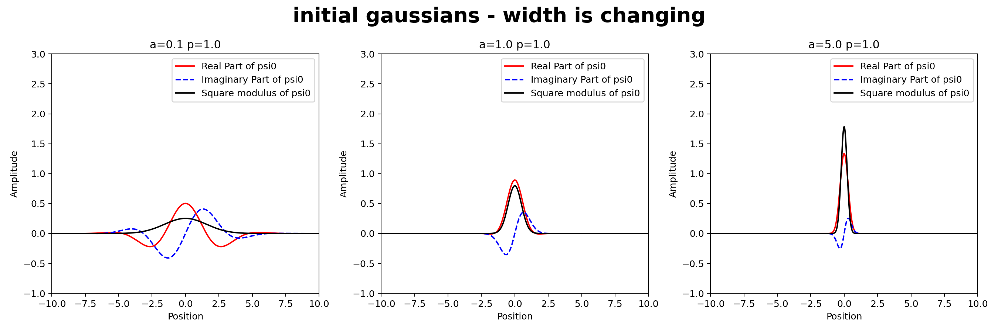
Figure 1. Initial Gaussian states for α=0.1, 1, and 5 at fixed p₀=1. The black curve is |ψ|²; red/blue curves are the real/imaginary parts.

1.2 Initial Gaussian: changing mean momentum p₀
At fixed α=1, as p₀ increases, the wavefunction oscillates more rapidly, while the probability density |ψ|² remains unchanged.
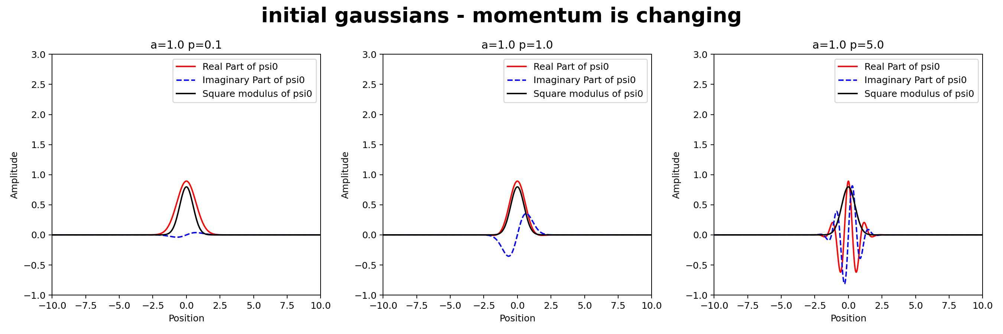
Figure 2. Initial Gaussian states for p₀=0.1, 1, and 5 at fixed α=1. The phase oscillates more rapidly as p₀ increases.

1.3 Free propagation and spreading (t>0)
The propagation formula above is used for the time snapshots. As time increases, the center of the free Gaussian wavepacket moves to the right with velocity p₀/m. At the same time, the wavepacket spreads in real space, so its spatial width increases continuously during propagation.
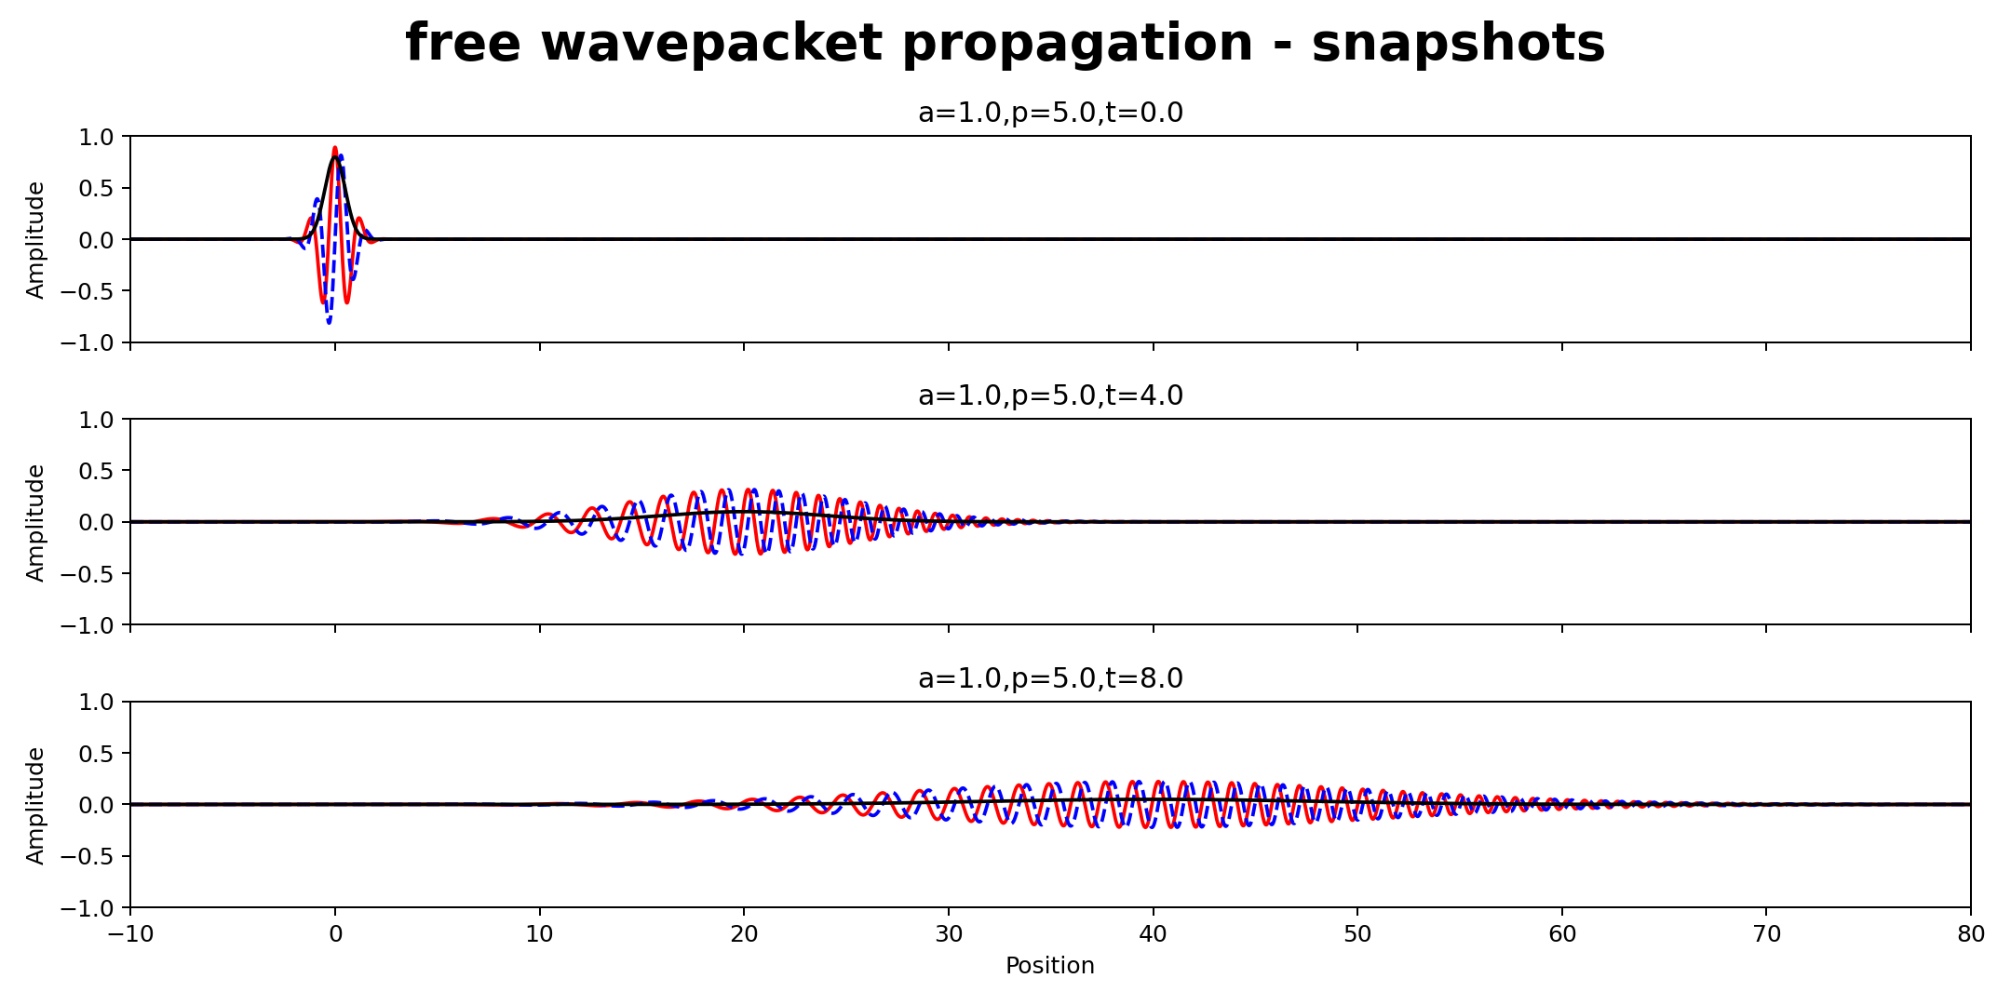
Figure 3. Free propagation snapshots for α=1, p₀=5. The wavepacket moves to the right at the expected group velocity and broadens with time.

2. Part 2 - Regularized Dirac delta function
The Dirac delta function is defined through its action on a smooth test function f(p):
$$\int_{−∞}^{+∞}{f(p) δ(p) dp} = f(0).$$
For the numerical calculation, the regularized Dirac delta function used in this project is
$$δ_{L}(p) = \frac{1}{2π} \int_{−L}^{L}{\exp\left(ipx\right) dx} = \frac{\sin\left(pL\right)}{πp}.$$
As L → ∞, the regularized function approaches the Dirac delta distribution, so that
$$\underset{L → ∞}{\text{lim}} \int_{−∞}^{+∞}{f(p) δ_{L}(p) dp} = f(0).$$

2.1 Numerical distribution test
For the numerical test, the smooth test function f(p) is chosen as the momentum-space Gaussian ϕ(p) from Part 1, with α=1 and p₀=5. The numerical integration window is fixed at p∈[-10,10] for every L.
L | $$\int{f(p) δ_{L}(p) dp}$$ | $$f(0)$$ | Absolute difference
10 | 0.0012166507 | 0.0012193111 | 2.660e-06
100 | 0.0012190874 | 0.0012193111 | 2.237e-07
1000 | 0.0012193480 | 0.0012193111 | 3.696e-08
The error decreases from 2.66×10⁻⁶ at L=10 to 3.70×10⁻⁸ at L=1000. The convergence toward f(0)=0.0012193111 is a direct numerical verification of the defining action of the Dirac delta distribution.

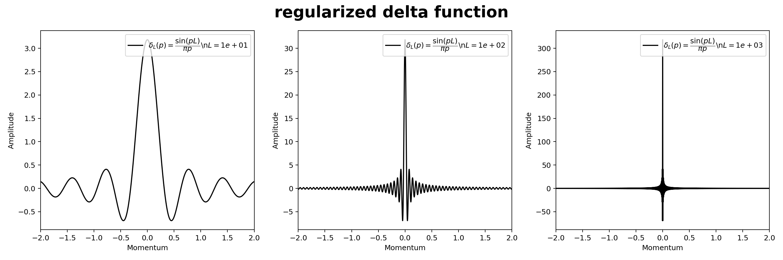 Figure 4. The regularized delta function for L=10, 100, and 1000. Increasing L concentrates the distribution more strongly around p=0.

3. Part 3 - Stationary scattering and resonances
For the interacting calculations, the potential is
$$V(x) = \left(0.5x^{2} − 0.8\right) \exp\left(−0.1x^{2}\right).$$
This is a symmetric central well surrounded by two barriers.

3.1 Numerical method
For each E>0, the physical stationary state for a particle incident from the left has the asymptotic form below, with k=√(2E) in the chosen units.
$$ψ_{E}(x → −∞) = \exp\left(ikx\right) + R(E) \exp\left(−ikx\right)$$
$$ψ_{E}(x → +∞) = T(E) \exp\left(ikx\right)$$
For the finite-difference calculation, a modified state with unit transmitted amplitude is used instead:
$${\overline{ψ}}_{E}(x → −∞) = A(E) \exp\left(ikx\right) + B(E) \exp\left(−ikx\right)$$
$${\overline{ψ}}_{E}(x → +∞) = \exp\left(ikx\right)$$
On an equally spaced spatial grid, the finite-difference Schrödinger equation can be written as
$${\overline{ψ}}_{E}(x_{n−1}) = \left[2 + 2{\left(Δx\right)}^{2}\left(V(x_{n}) − E\right)\right] {\overline{ψ}}_{E}(x_{n}) − {\overline{ψ}}_{E}(x_{n+1}).$$
Starting from two grid points in the right free region, this relation propagates the modified state step by step toward the left. In the left free region, A(E) and B(E) are obtained from the numerical wavefunction.
$$ψ_{E}(x) = \frac{{\overline{ψ}}_{E}(x)}{A(E)}, T(E) = \frac{1}{A(E)}, R(E) = \frac{B(E)}{A(E)}.$$
The physical transmission and reflection probabilities are |T|² and |R|², with |T|²+|R|²=1 as the numerical consistency check.

3.2 Transmission spectrum
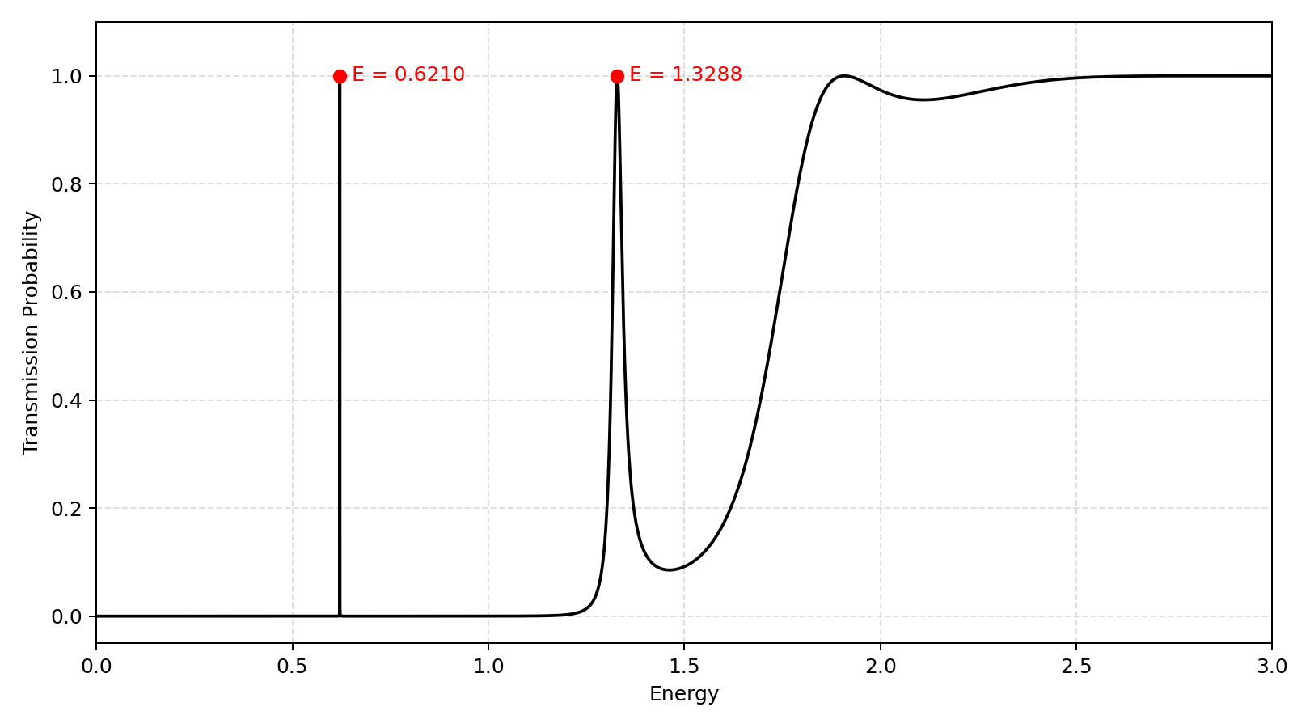
Figure 5. Calculated transmission probability over 0<E<3. Two sharp below-barrier resonances are visible at E≈0.6210 and E≈1.3288; at higher energy the transmission tends toward unity.
The transmission spectrum shows two narrow resonance peaks at E≈0.6210 and E≈1.3288, where the transmission probability reaches almost one. At higher energies, the transmission gradually approaches one.
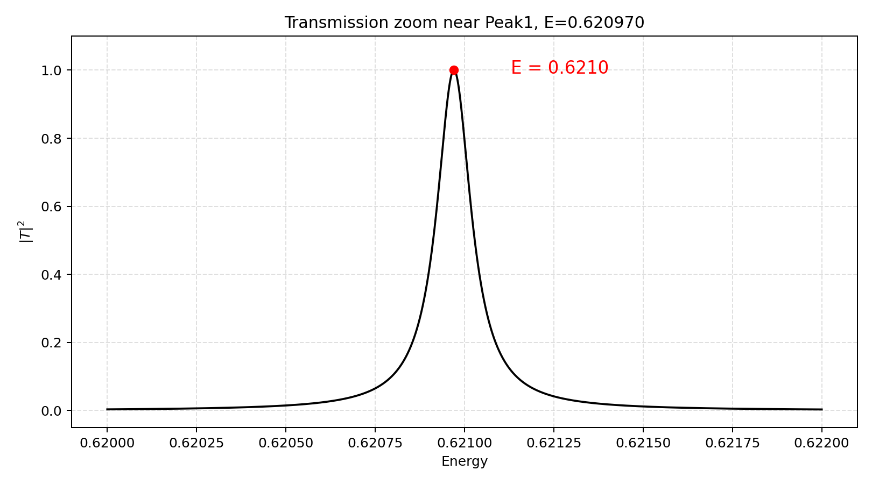 | 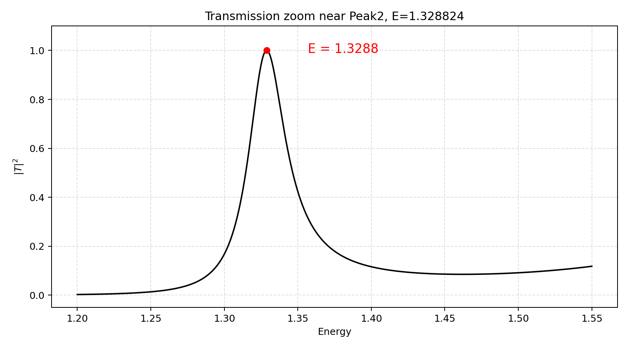
Figure 6a. Zoom of the first peak at E≈0.6210 | Figure 6b. Zoom of the second peak E≈1.3288

3.3 Continuum wavefunctions around the resonances
The following panels show the modified state ψ̄ defined in Section 3.1.
First resonance. At E=0.40 and E=0.75, the physical transmission is almost zero and the wave is almost completely reflected. At the resonance energy E≈0.62097, |T|²≈1 and the wave is almost perfectly transmitted through the potential, and a large oscillation is also formed inside the central well.
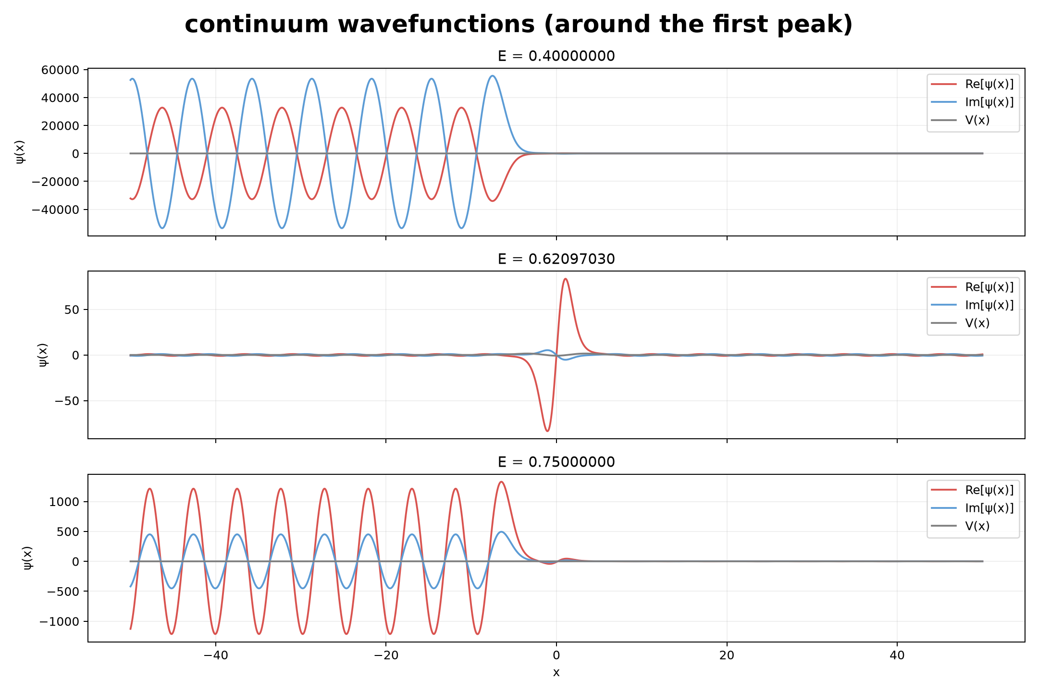
Figure 7. Modified continuum wavefunctions around the first resonance.
Second resonance. The same behavior appears around E≈1.32882. Away from the peak (E=1.00 and E=1.60), the transmission is much smaller, whereas at the resonance |T|²≈1 and the wave is almost perfectly transmitted through the potential, and a large oscillation is also formed inside the central well.
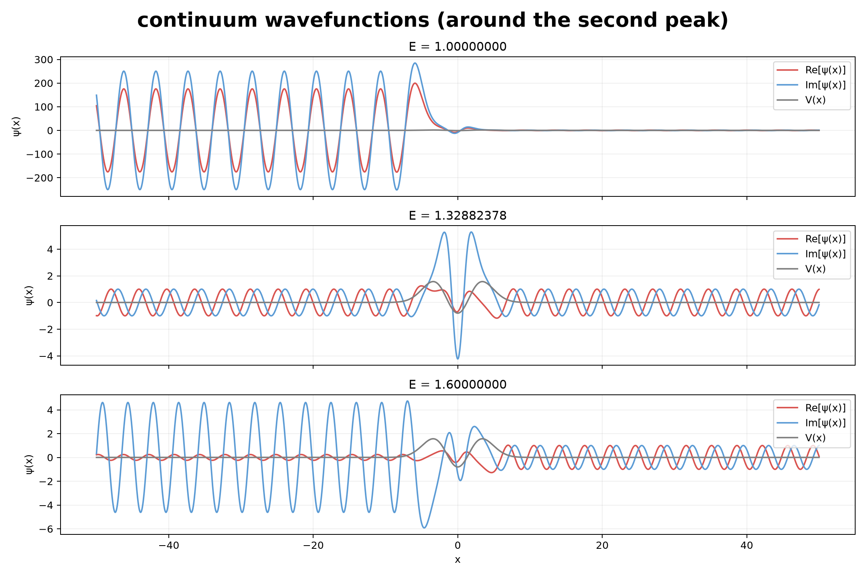
Figure 8. Modified continuum wavefunctions around the second resonance.

4. Part 4 - Wavepacket scattering
In Part 4, a Gaussian wavepacket is used as the incident wavepacket. It is constructed by superposing the left-incident stationary scattering states obtained in Part 3 with a Gaussian momentum distribution:
$$Ψ(t,x) = \int{ϕ(p) ψ_{p}(x) \exp\left(−iE(p)t\right) dp}, E(p) = \frac{p^{2}}{2}.$$
Here ϕ(p) is the momentum-space coefficient of the incident Gaussian,
$$ϕ(p) = \frac{1}{\sqrt{2π}} \int{Ψ(0,x) \exp\left(−ipx\right) dx}.$$
The function ψₚ(x) is the left-incident stationary scattering state calculated in Part 3, while exp[-iE(p)t] gives the time evolution of each momentum component. The Gaussian distribution |ϕ(p)|² is centered at p₀, and its width determines which part of the transmission spectrum is included in the wavepacket. For the Gaussian convention used in Part 1, Δp=√α under ħ=1.

4.1 Blocked packet
The blocked packet is centered at E₀=1.0, well below the barrier top and away from either resonant peak. Across the relevant momentum distribution the transmission is extremely small. Therefore, almost the entire wavepacket is reflected back to the left. The snapshots show exactly this: the packet approaches the barrier, overlaps the potential well region, and then comes back as a reflected packet with negligible transmitted weight.
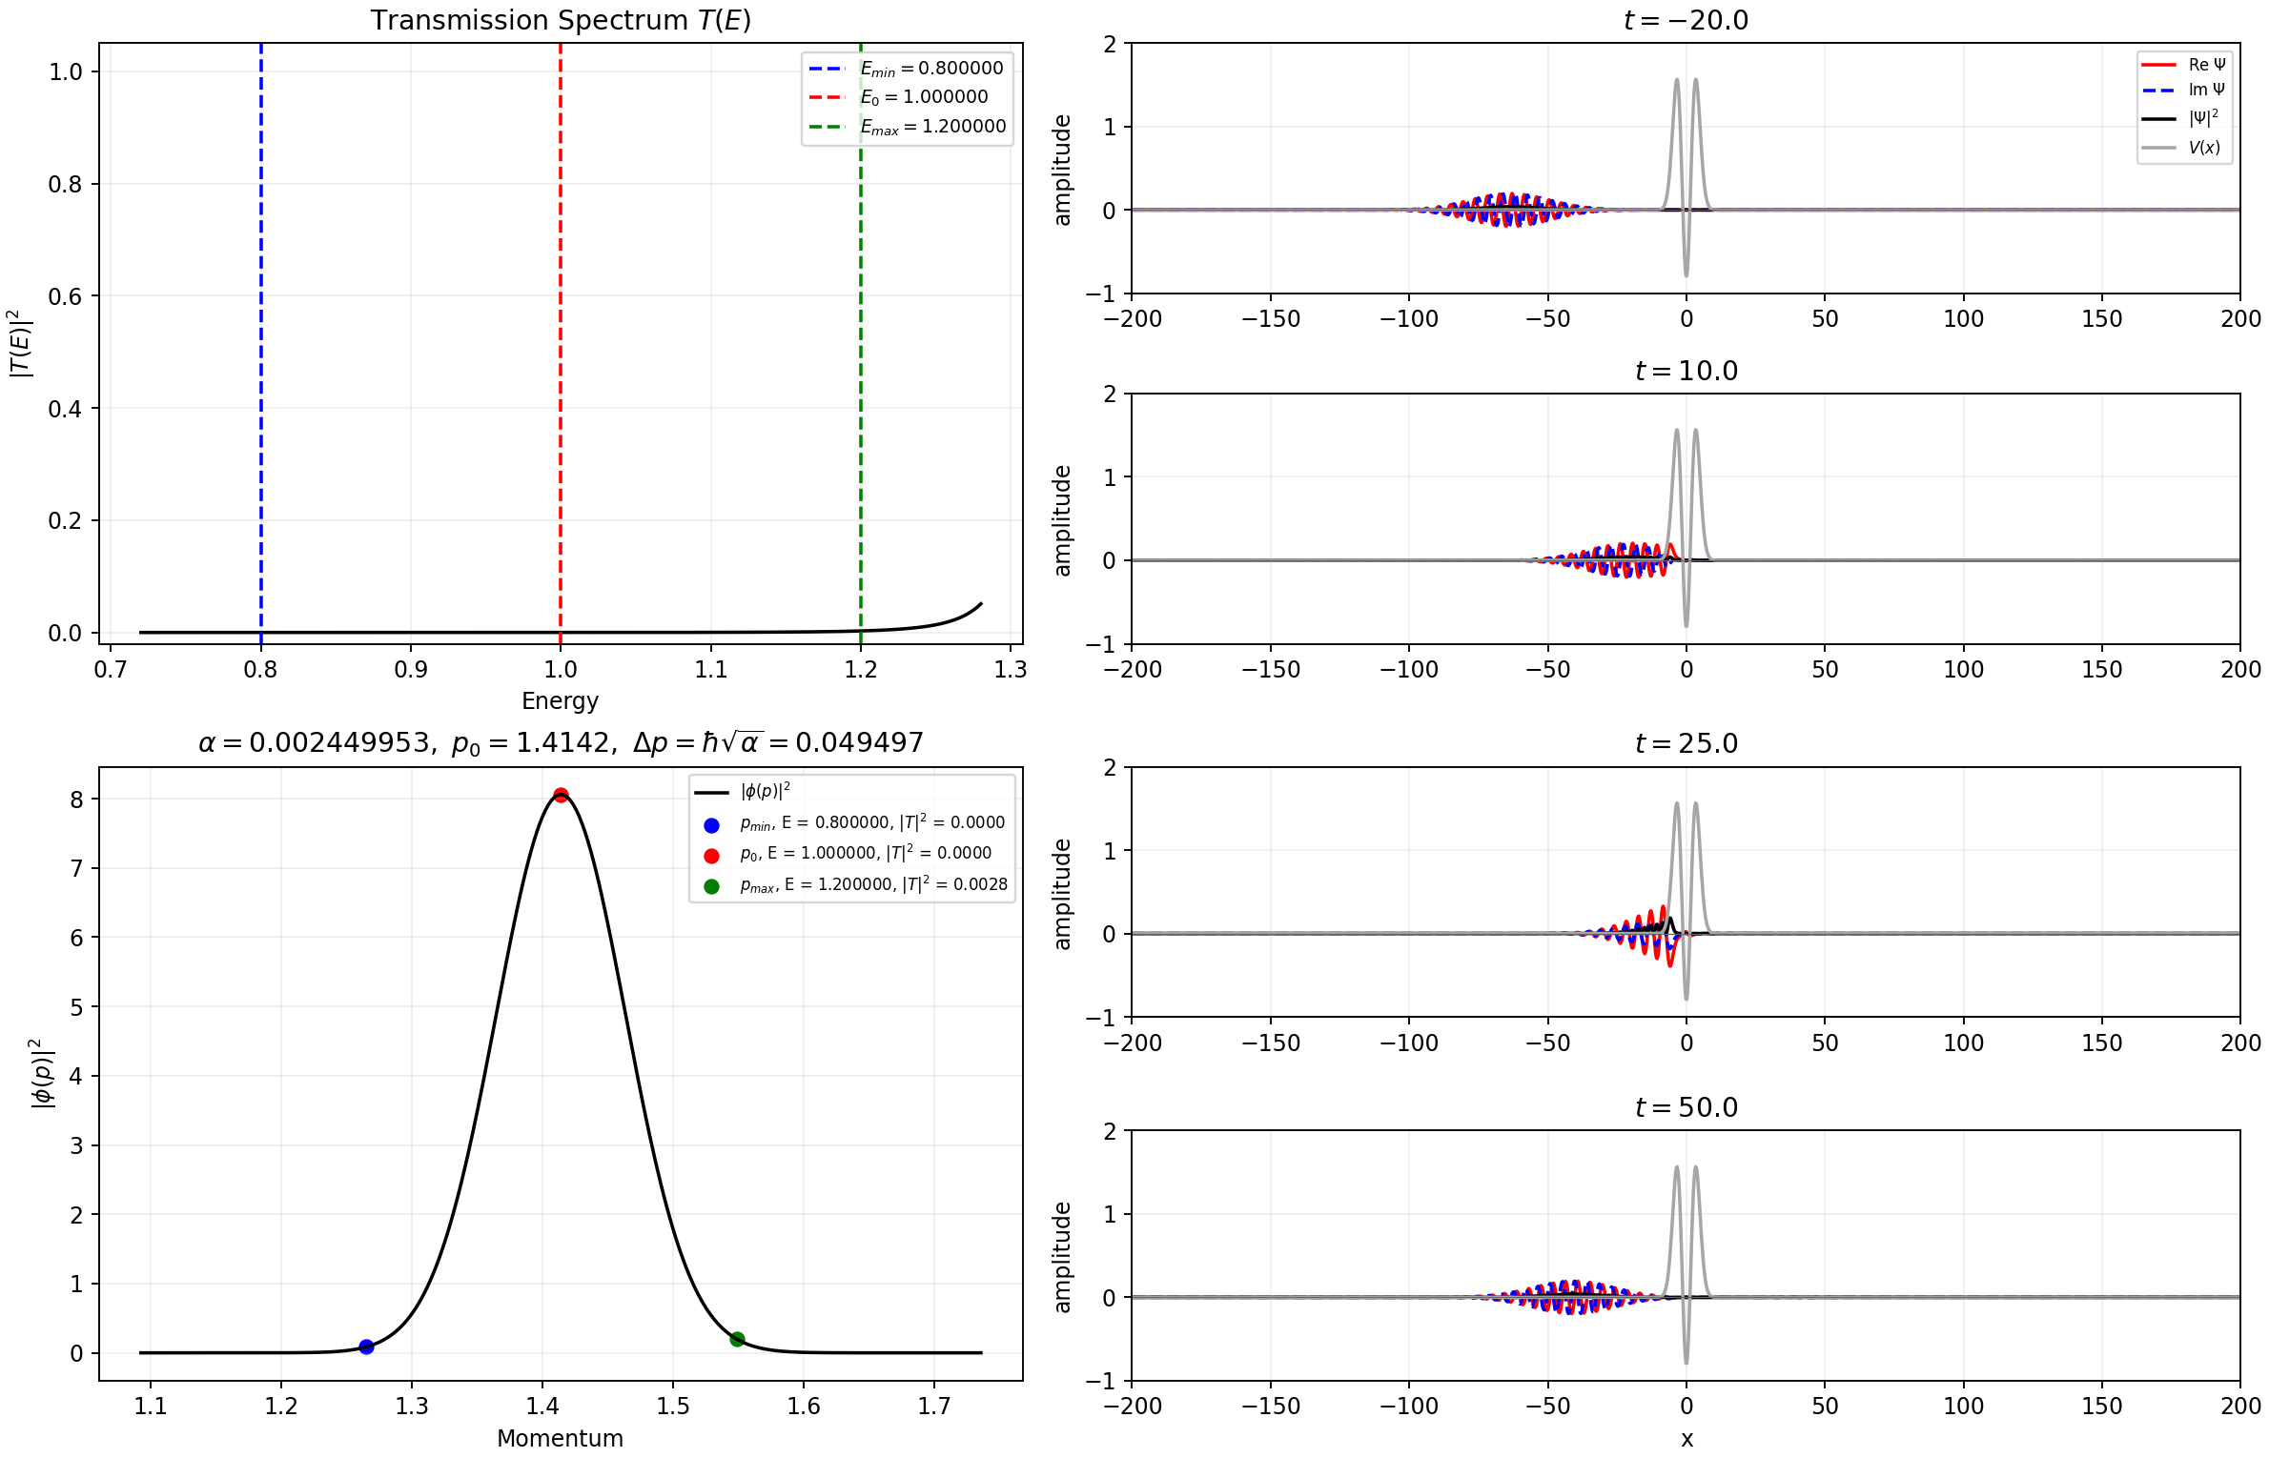
Figure 9. Blocked scenario. Left: stationary transmission spectrum and incident momentum density. Right: time snapshots showing almost complete reflection.

4.2 Partially blocked packet
The reference center E₀=1.328814 lies essentially on the second resonance peak, but the packet has a much larger finite momentum width Δp=0.015556. Consequently only part of the incident spectrum sits in the high-transmission resonance region; neighboring components have much smaller |T|². Therefore, only the momentum components whose energies lie within the second resonance peak can be transmitted efficiently. Components whose energies deviate too far from the resonance have much smaller transmission probabilities and are reflected back to the left.
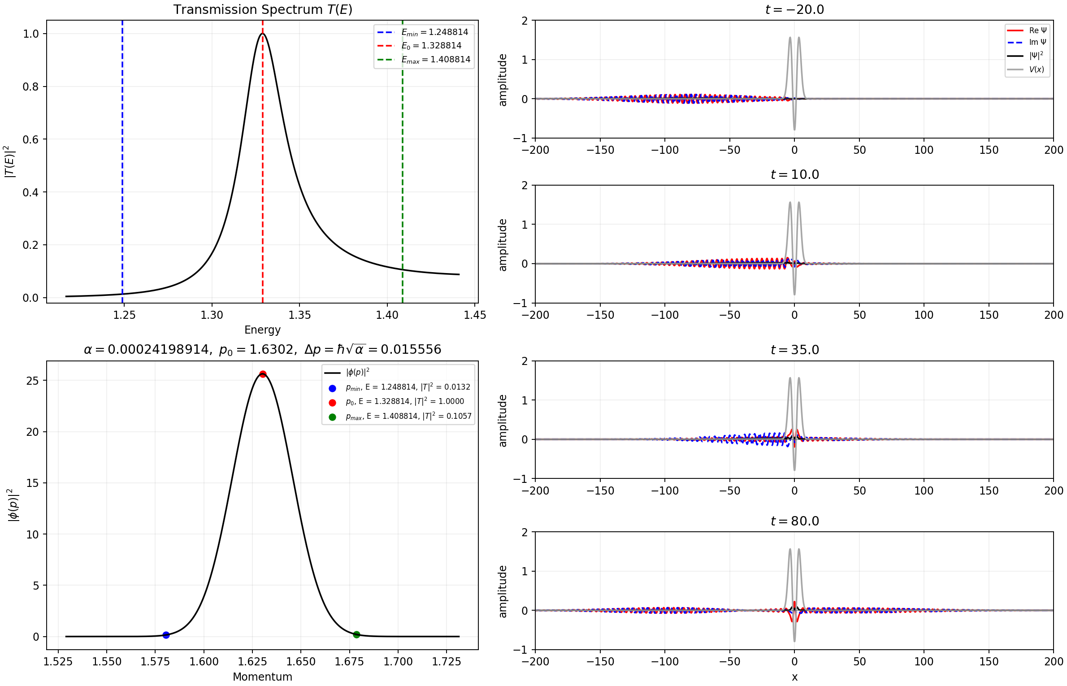
Figure 10. Partially blocked scenario centered near the second resonance. The finite spectral width covers both resonant and non-resonant energies, producing simultaneous transmission and reflection.

4.3 Passing packet
For E₀=2.7, the transmission probability is close to one over almost the whole momentum distribution. Therefore, almost all components of the wavepacket pass through the potential region and continue propagating to the right, with only a very small reflected part.
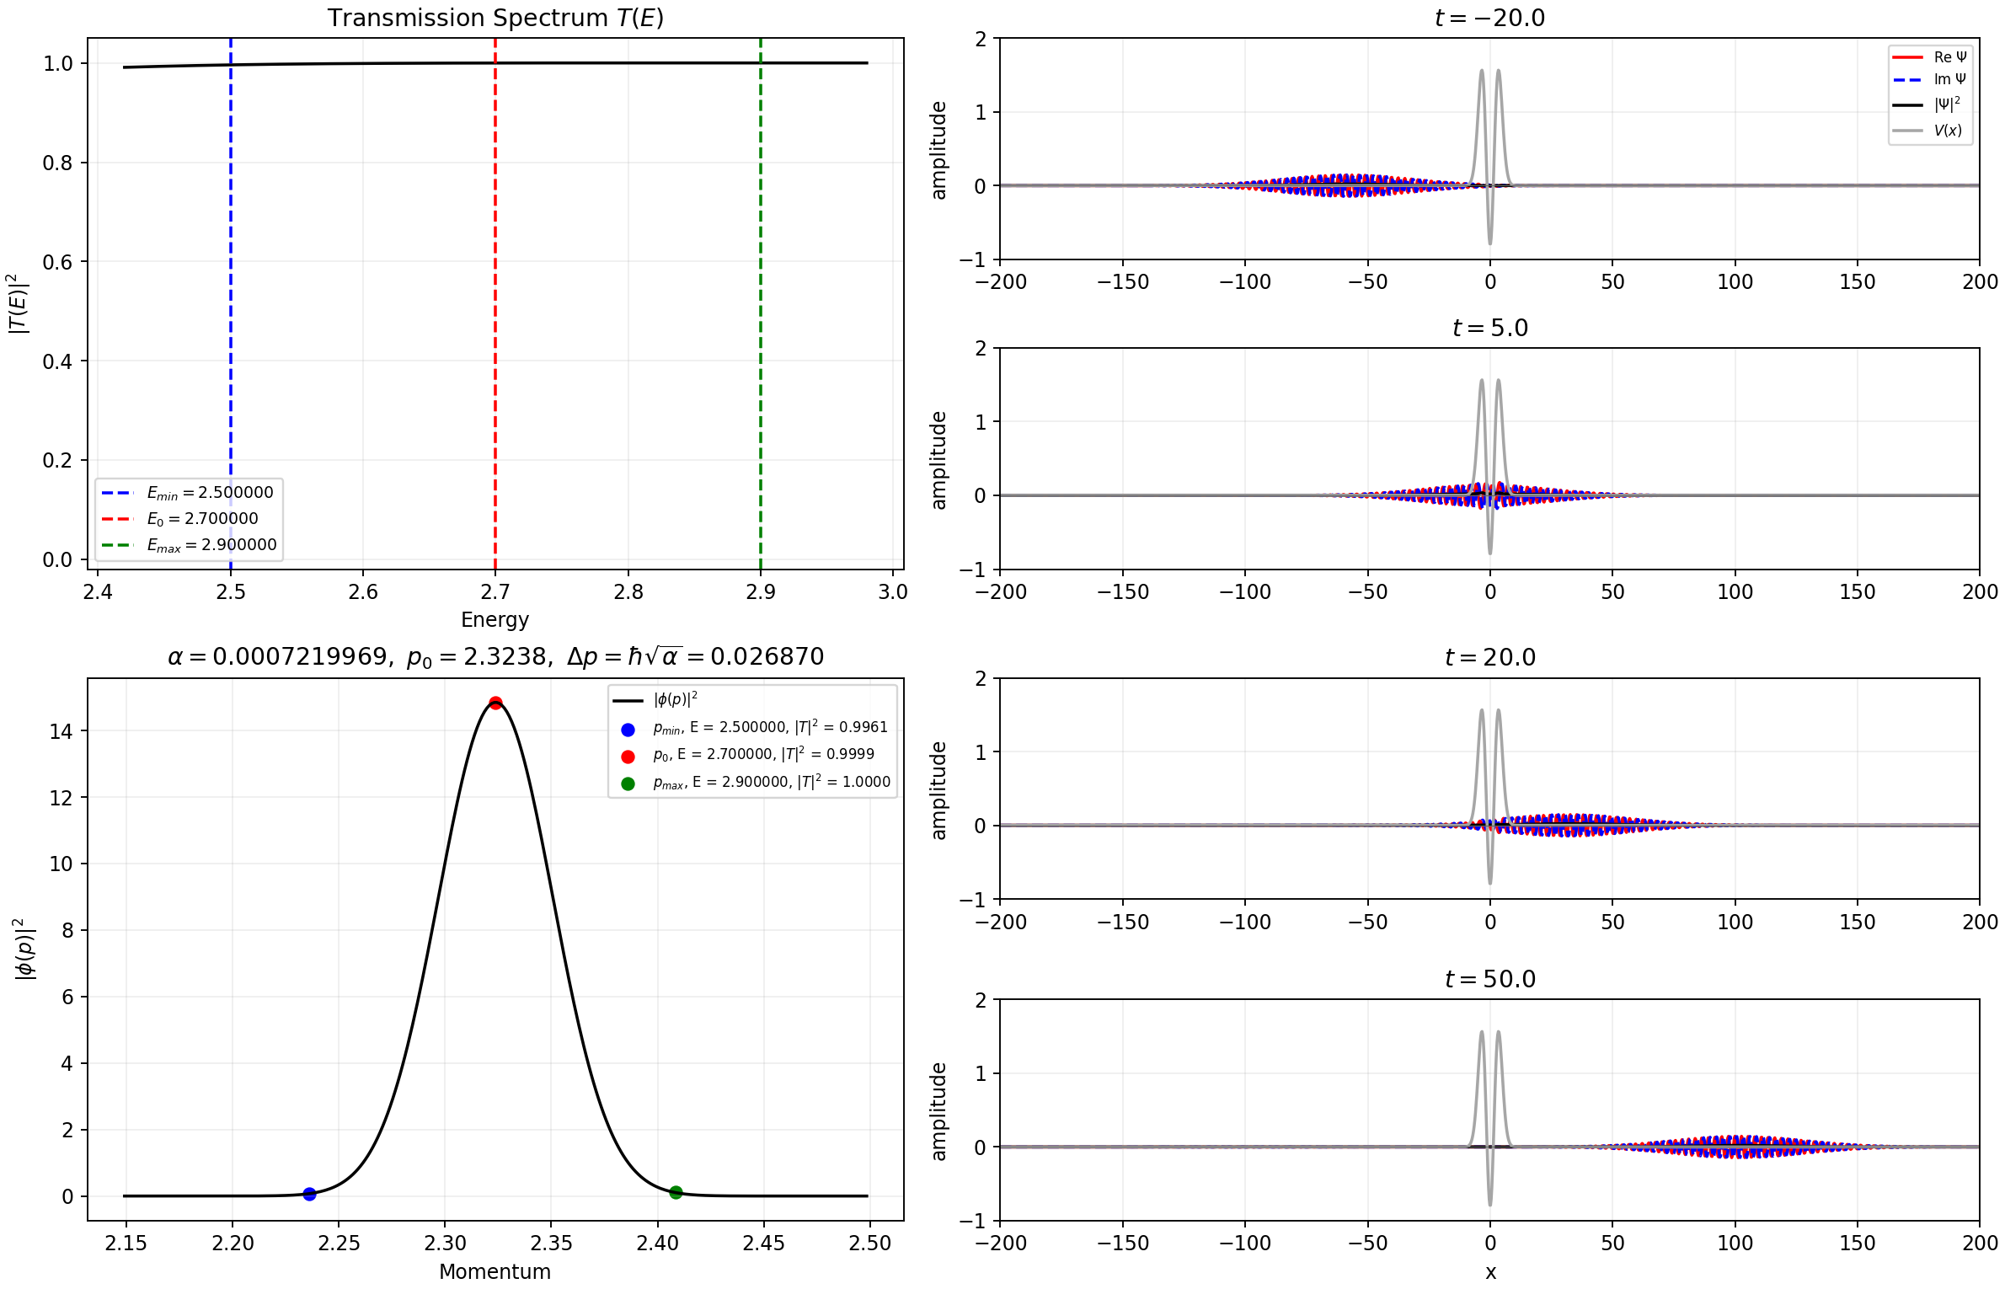
Figure 11. Passing scenario at high energy. Nearly the entire wavepacket crosses the potential.

4.4 Narrow range at first resonance peak
This case uses an extremely narrow momentum range centered on the first resonance peak. Since almost the entire range lies within the high-transmission region, the transmission probability is close to one for nearly all components of the wavepacket. Therefore, most of the wavepacket passes through the potential.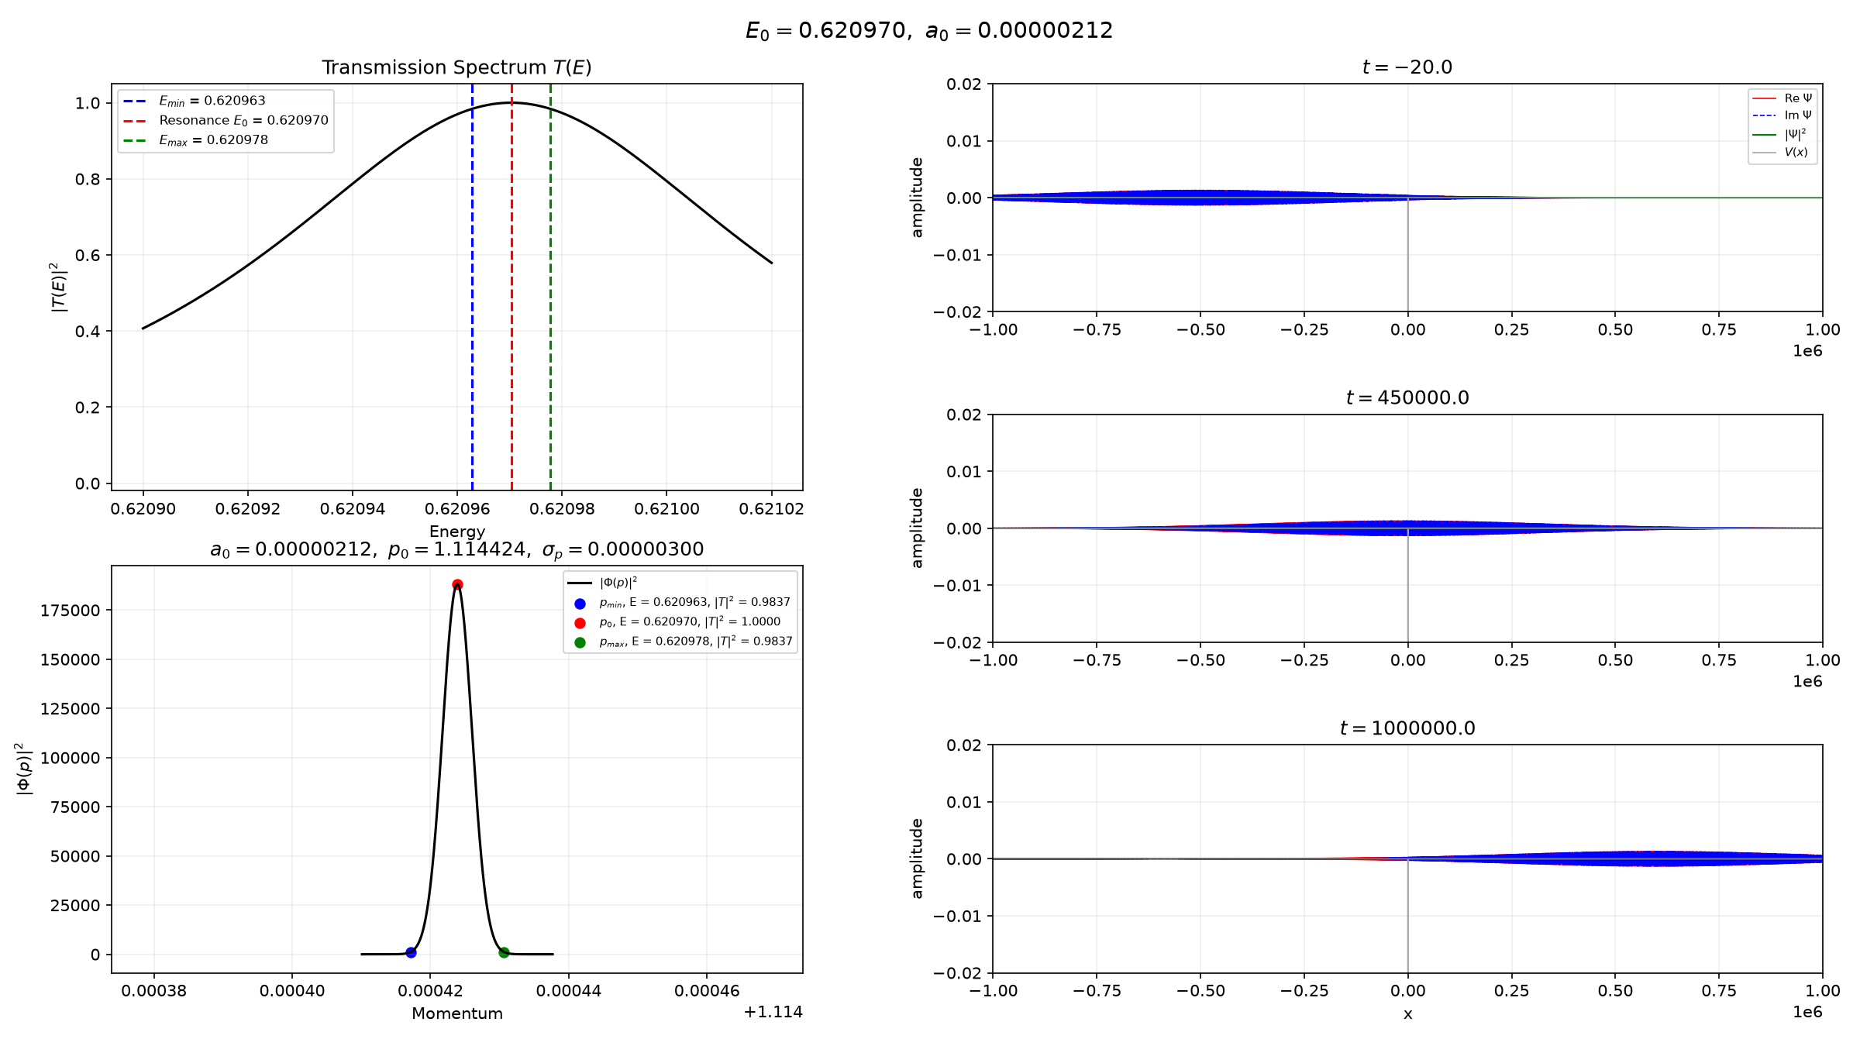
Figure 12. First-resonance packet centered at E₀=0.62097030. The three full-range snapshots show the real and imaginary parts before, during and after transmission.

4.5 Narrow range at second resonance peak
This case uses a very narrow momentum range centered on the second resonance peak. Since almost the entire range lies within the high-transmission region, the transmission probability is close to one for nearly all components of the wavepacket. Therefore, most of the wavepacket passes through the potential.
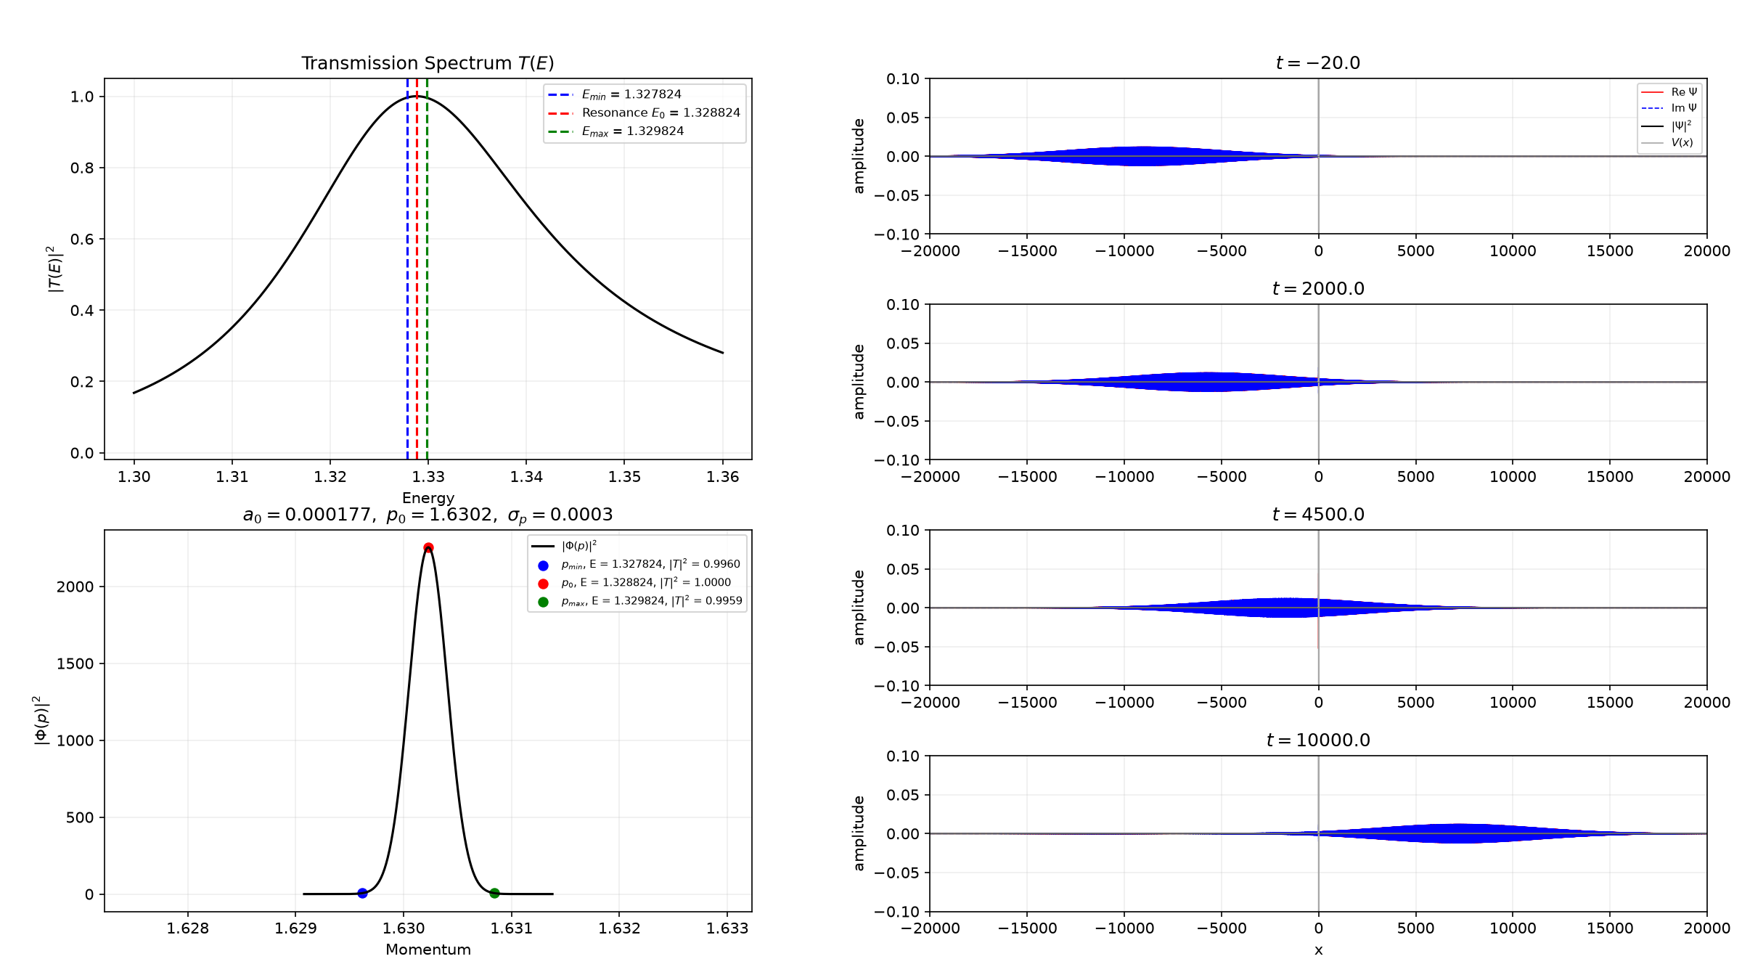
Figure 13. Extremely narrow-band packet centered exactly at the numerically determined second resonance. Its large spatial width is the Fourier counterpart of the tiny momentum width.

5. Part 5 - Box-basis eigenstates
In Part 5, the stationary Schrödinger equation is written as a matrix eigenvalue problem in a finite box. The particle-in-a-box basis is
$$φ_{j}(x) = \sqrt{\frac{2}{L}} \sin\left[\frac{jπ\left(x + \frac{L}{2}\right)}{L}\right], −\frac{L}{2} ≤ x ≤ \frac{L}{2}.$$
The eigenfunctions are expanded in this basis as
$$ψ_{n}(x) = \sum_{j=1}^{J}{c_{j}^{(n)} φ_{j}(x)}.$$
For m=ℏ=1, the Hamiltonian matrix contains a kinetic-energy part and a potential-energy part,
$$H_{ij} = T_{ij} + V_{ij}.$$
For the sine basis, the kinetic-energy part is diagonal:
$$T_{ij} = \frac{j^{2}π^{2}}{2L^{2}} δ_{ij}.$$
This is because the sine functions are orthogonal eigenfunctions of the particle-in-a-box kinetic-energy operator. The potential-energy part is
$$V_{ij} = \int_{−\frac{L}{2}}^{\frac{L}{2}}{φ_{i}(x)V(x)φ_{j}(x) dx},$$
which can connect different basis functions.
The complete Hamiltonian matrix is then diagonalized,
$$H c^{(n)} = E_{n} c^{(n)},$$
to obtain the energies and the coefficients of each eigenfunction.
The finite box changes the positive-energy continuum into a discrete set of eigenvalues.
Here J is the number of basis functions, L is the box length, and N is the number of x points used for the numerical integrals.

5.1 Harmonic-oscillator validation
First, the method is tested with the harmonic oscillator V(x)=x²/2-0.8, whose exact energies are Eₙ=n-0.3. The calculated energies are close to these values, showing that the box-basis method gives the expected spectrum.
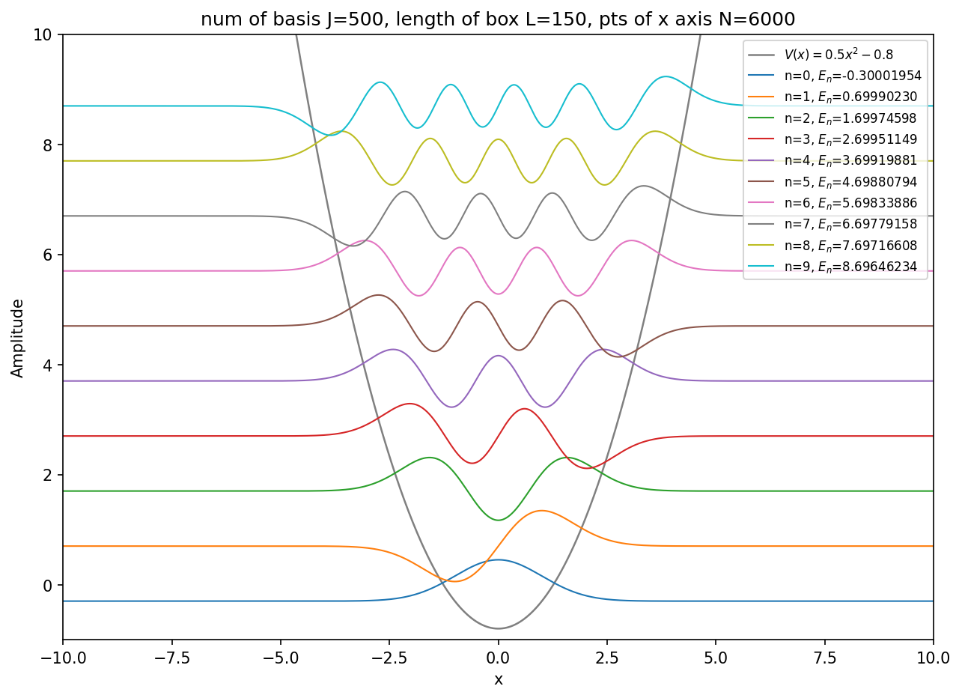
Figure 14. Harmonic-oscillator validation with J=500, L=150 and N=6000. The first ten energy-shifted eigenfunctions are shown with the potential.

5.2 First eigenstates of the short-range potential
For the short-range potential, J=600, L=200 and N=10000 are used. The lowest eigenvalue is E₀=-0.29795964. Its wavefunction is concentrated around the central well, so it is a bound state. The next ten eigenvalues are positive, and their wavefunctions extend across the box. Therefore, they are discretized continuum states rather than additional bound states.
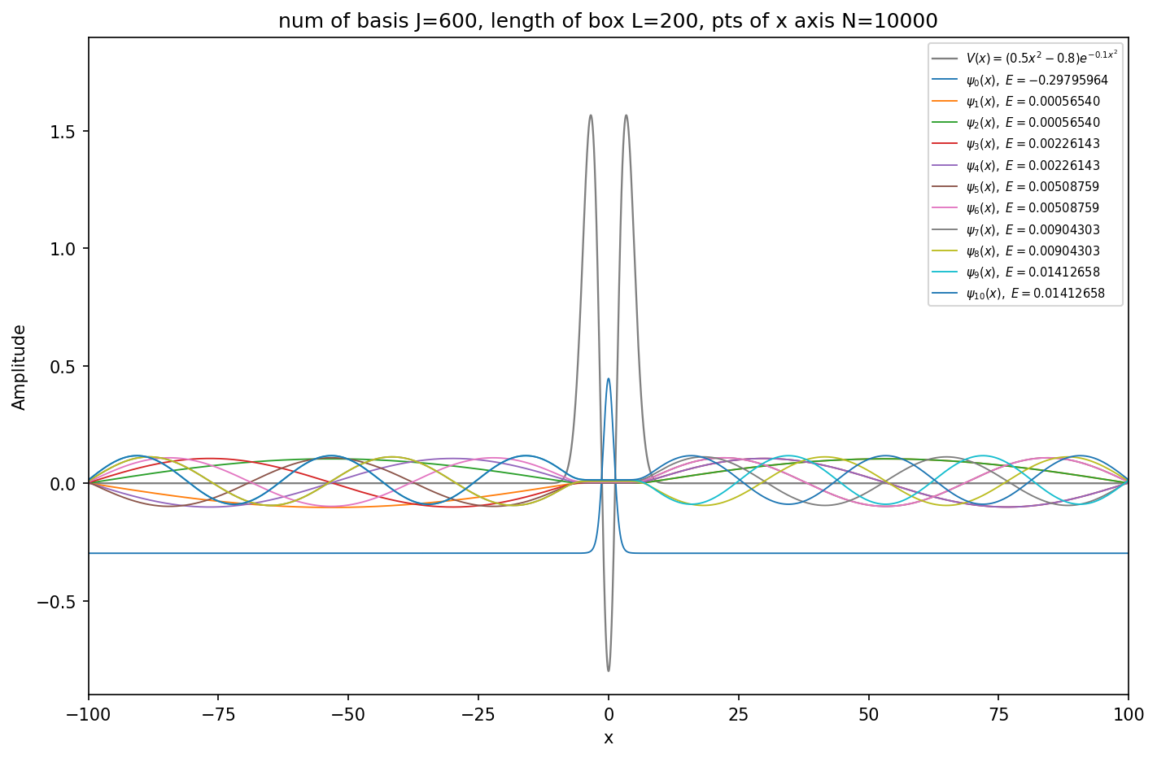
Figure 15. First 11 box eigenstates of the short-range potential. The negative-energy ground state is localized, while the positive-energy states extend through the finite box.
The same states are shown separately below. The number of oscillations increases with energy, whereas the negative-energy ground state remains localized near x=0.
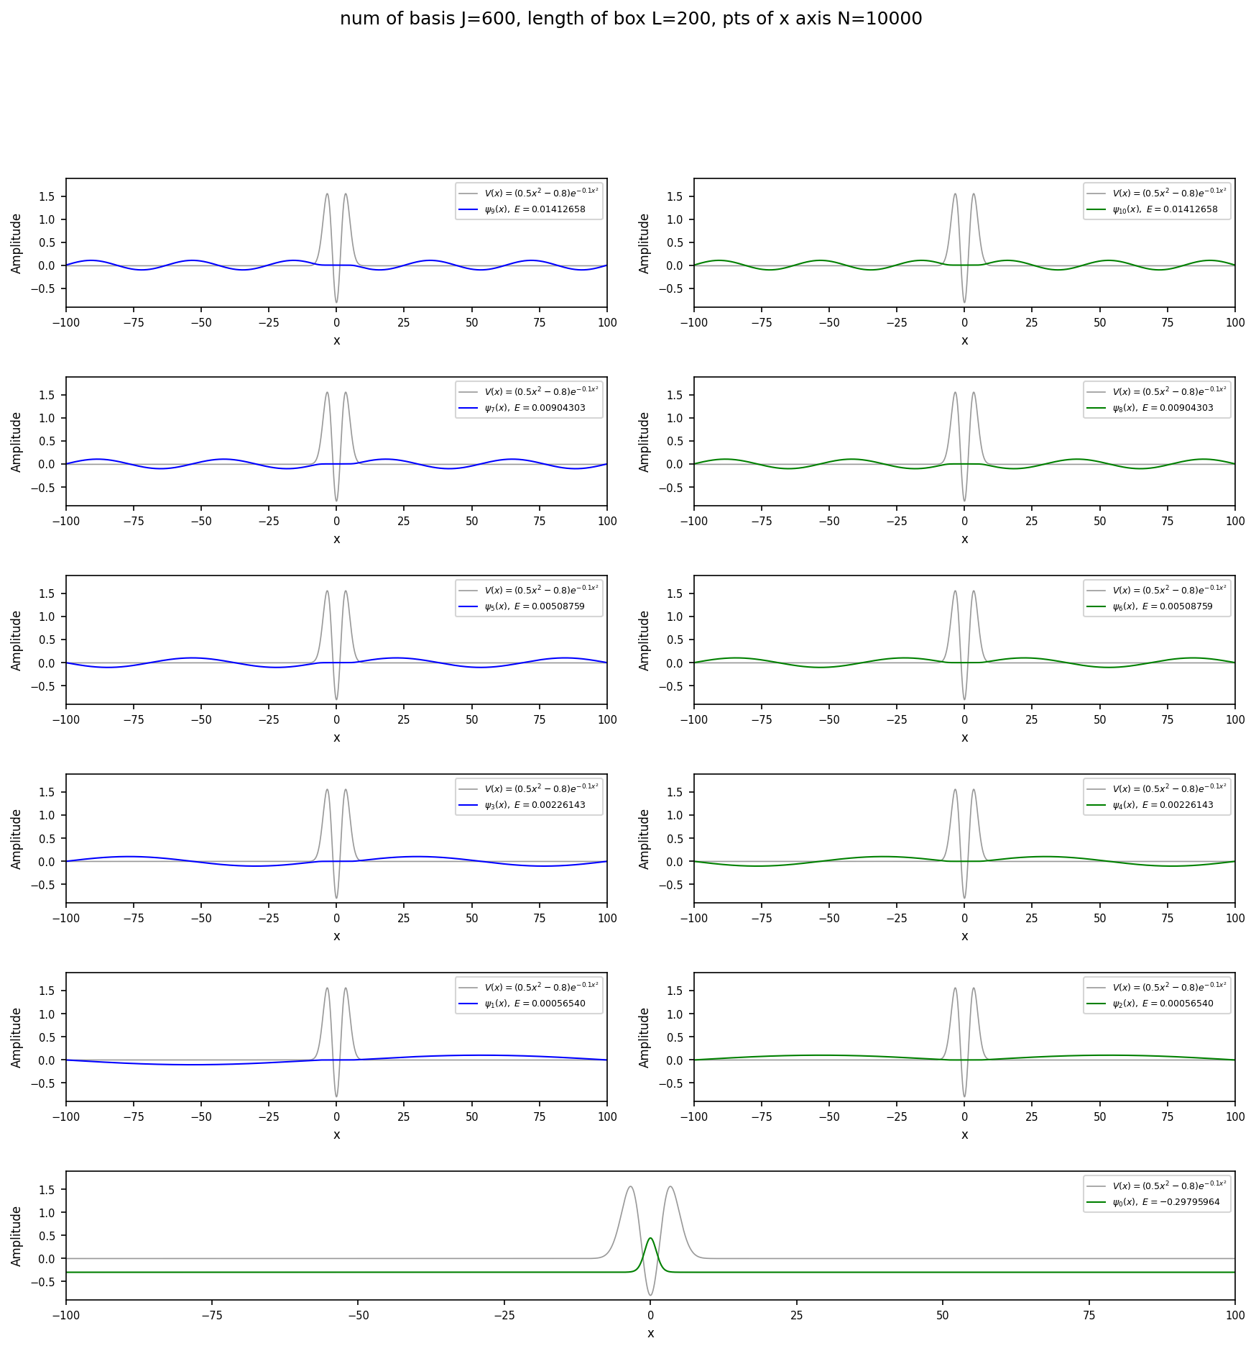
Figure 16. The first 11 eigenstates shown separately. The positive-energy states oscillate across the box and vanish at the two box boundaries.

5.3 All box eigenstates
With J=201, the calculation produces 201 discrete box eigenstates. Only the lowest state has E<0. The many states with E>0 fill the finite box and represent the scattering continuum after the box boundary has made it discrete.
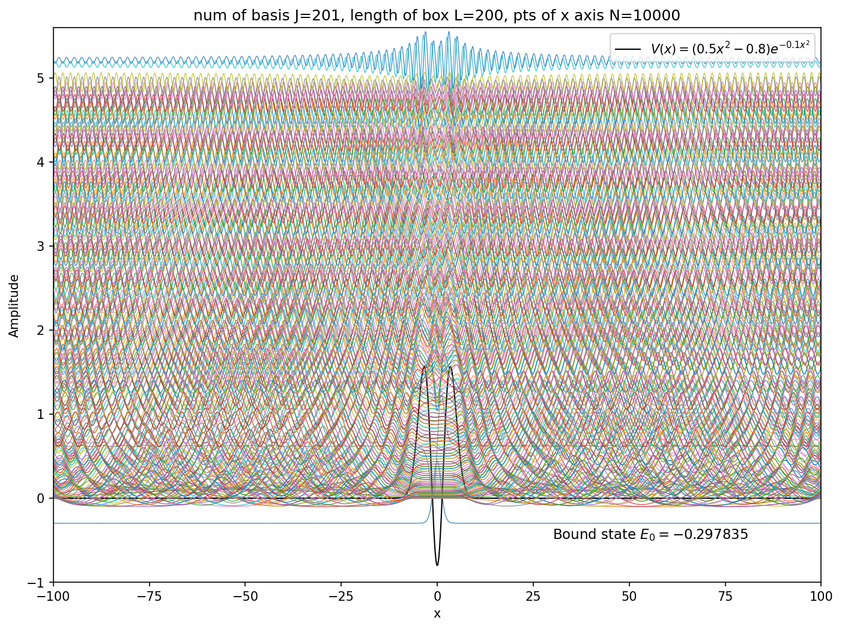
Figure 17. All 201 finite-box eigenstates for L=200. One negative-energy bound state lies below the dense set of positive-energy box states.

5.4 Bound state and resonance-like box states
Three states are selected from the larger J=2000 calculation. The first is the bound state at E=-0.29795964. The other two have E=0.62097222 and E=1.33028105, close to the two transmission peaks from Part 3 at E=0.62097030 and E=1.32882395. Thus, two positive-energy box states are found close to the resonance energies obtained in Part 3.
The state near the first resonance is more concentrated around the central region, while the state near the second resonance has larger oscillatory tails outside the potential.
However, the two E>0 states are not bound states. Their wavefunctions still have oscillatory tails outside the potential, and their exact box eigenvalues change when L is changed.
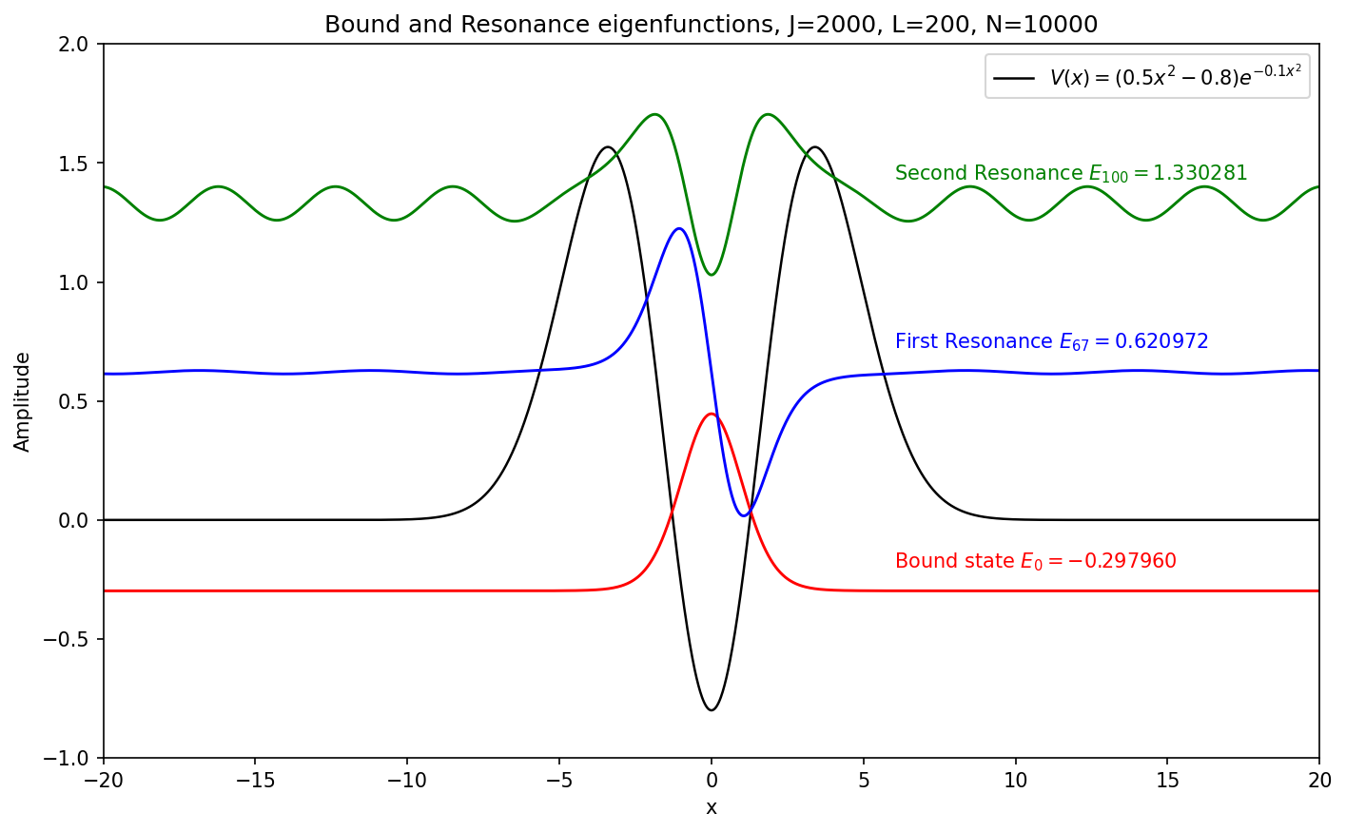
Figure 18. The bound state and two positive-energy box eigenstates selected near the Part 3 resonance energies. The first resonance-like state is more strongly concentrated around the central region.

6. Part 6 - Complex scaling and resonance states
Part 6 uses the box-basis method from Part 5 after rotating the spatial coordinate into the complex plane, x→x exp(iθ). For the same short-range potential, the complex-scaled Hamiltonian is
$$H_{θ} = \exp\left(−2iθ\right)T + V\left[x \exp\left(iθ\right)\right] = −\frac{1}{2} \exp\left(−2iθ\right) \frac{d^{2}}{dx^{2}} + V\left[x \exp\left(iθ\right)\right].$$
The kinetic-energy matrix is multiplied by exp(−2iθ), while the potential matrix is evaluated at the complex coordinate. The resulting non-Hermitian matrix is diagonalized in the same sine basis:
$$H_{θ} c^{(n)} = E_{n}(θ)c^{(n)}.$$
The calculation uses J=2000, L=200 and N=10000 for θ=0, 0.05, 0.10, 0.15, 0.20 and 0.25. As θ increases, the discretized continuum rotates downward in the complex-energy plane by approximately 2θ, whereas resonance eigenvalues remain nearly unchanged. These stable points can therefore be selected as complex resonance energies.
Each resonance energy is written as
$$E_{n} = E_{res,n} − i\frac{Γ_{n}}{2}, Γ_{n} = −2 \text{Im}\left(E_{n}\right).$$
The real part Eres,n gives the center of the transmission peak. The positive quantity Γₙ gives the full width at half maximum of an isolated Breit-Wigner peak:
$${\left|T(E)\right|}^{2} ≈ \frac{{\left(\frac{Γ_{n}}{2}\right)}^{2}}{\left[{\left(E − E_{res,n}\right)}^{2} + {\left(\frac{Γ_{n}}{2}\right)}^{2}\right]}.$$
Thus, a pole closer to the real axis produces a narrower peak, while a pole with a larger negative imaginary part produces a broader peak. The same rotation also gives ψθ(x)=ψ[x exp(iθ)]. For a sufficiently large θ, the outward growth of a Siegert resonance state becomes decay, so the state can be treated numerically in a finite basis.

6.1 Complex eigenvalue spectra
At θ=0, the discretized continuum lies on the real-energy axis. As θ increases, these states rotate into the lower half of the complex-energy plane. A few isolated eigenvalues remain almost at the same positions; these are the resonance states.
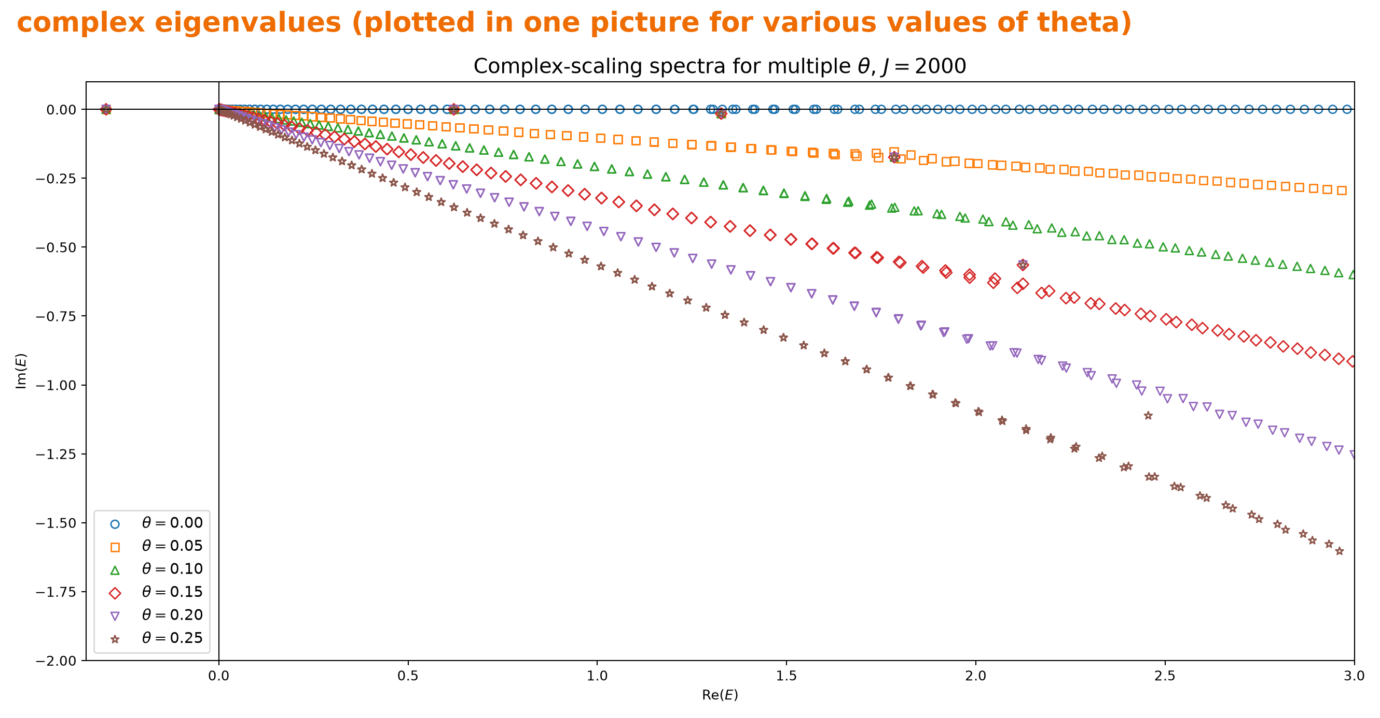
Figure 19. Complex-scaled eigenvalues for several values of θ. The continuum rotates downward, while isolated resonance eigenvalues remain nearly fixed.

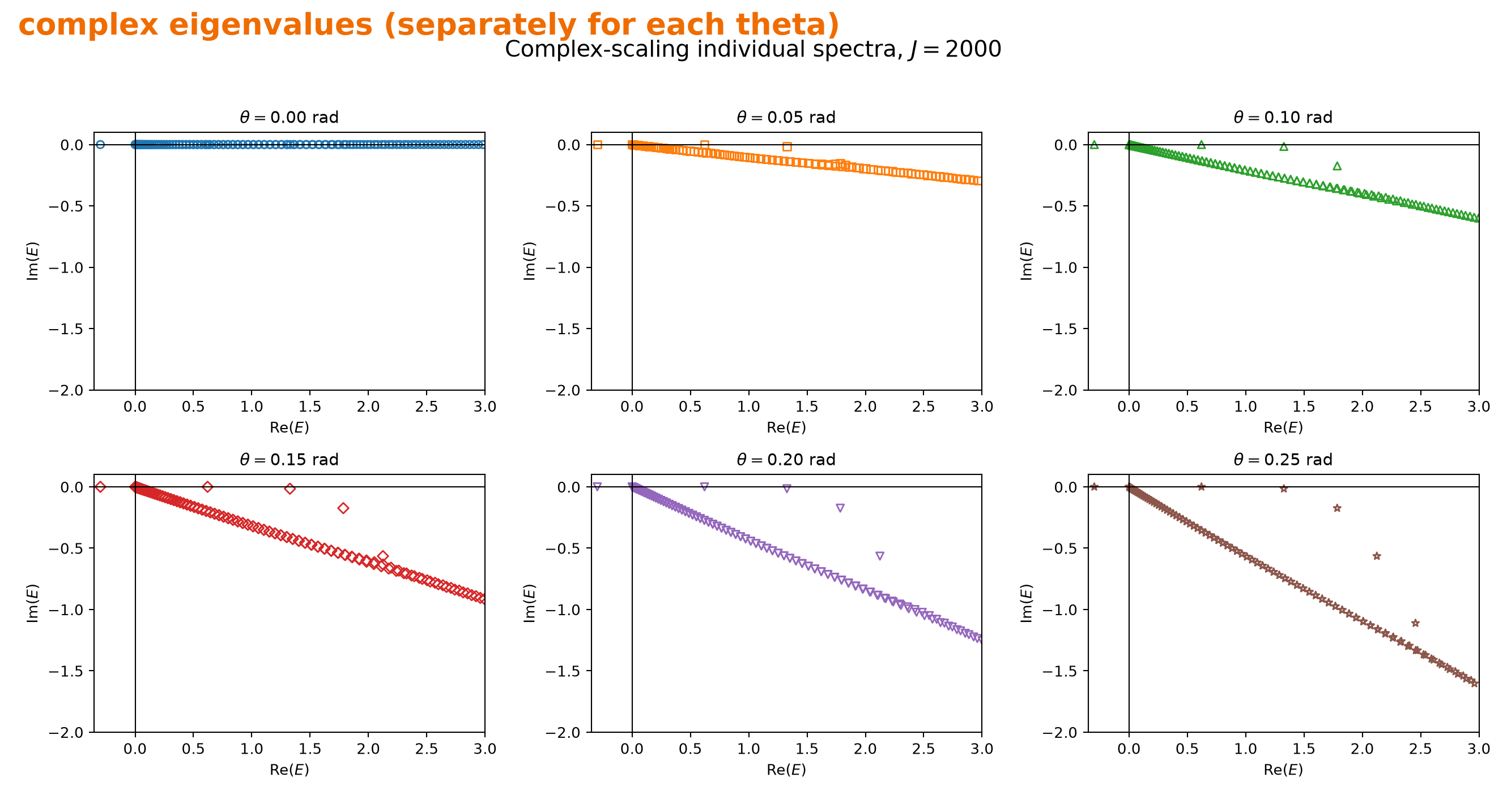
Figure 20. Individual panels for θ=0, 0.05, 0.10, 0.15, 0.20 and 0.25, making the motion of the continuum easier to follow.
The two lowest stable points are E₁≈0.620971−0.000058i and E₂≈1.327197−0.015447i. Their real parts lie near the Part 3 transmission maxima. Using Γ=−2 Im(E) gives Γ₁≈0.000116 and Γ₂≈0.030894. The much smaller Γ₁ explains why the first transmission peak is so sharp.

6.2 Breit-Wigner profiles
The complex resonance energies obtained above are substituted into the Breit-Wigner expression and compared with the Hermitian transmission probability calculated in Part 3.
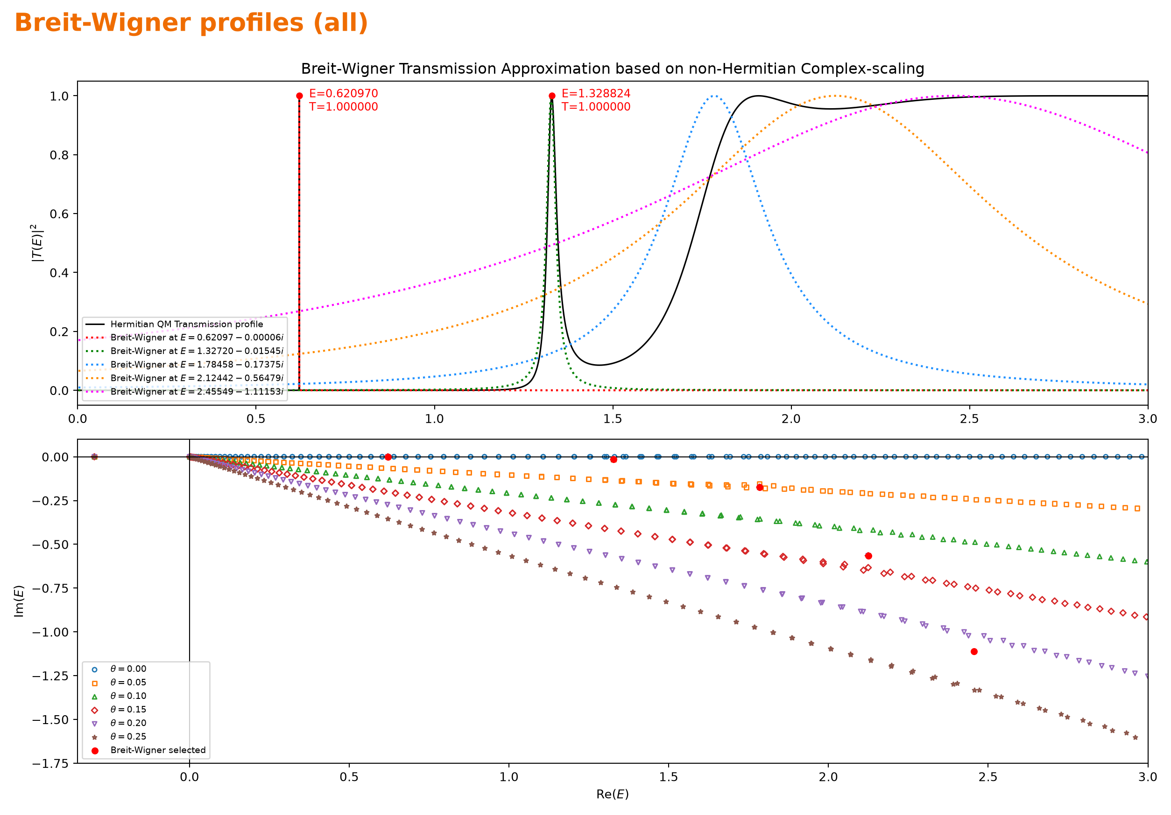
Figure 21. The Hermitian transmission profile compared with Breit-Wigner profiles obtained from the selected complex resonance energies.
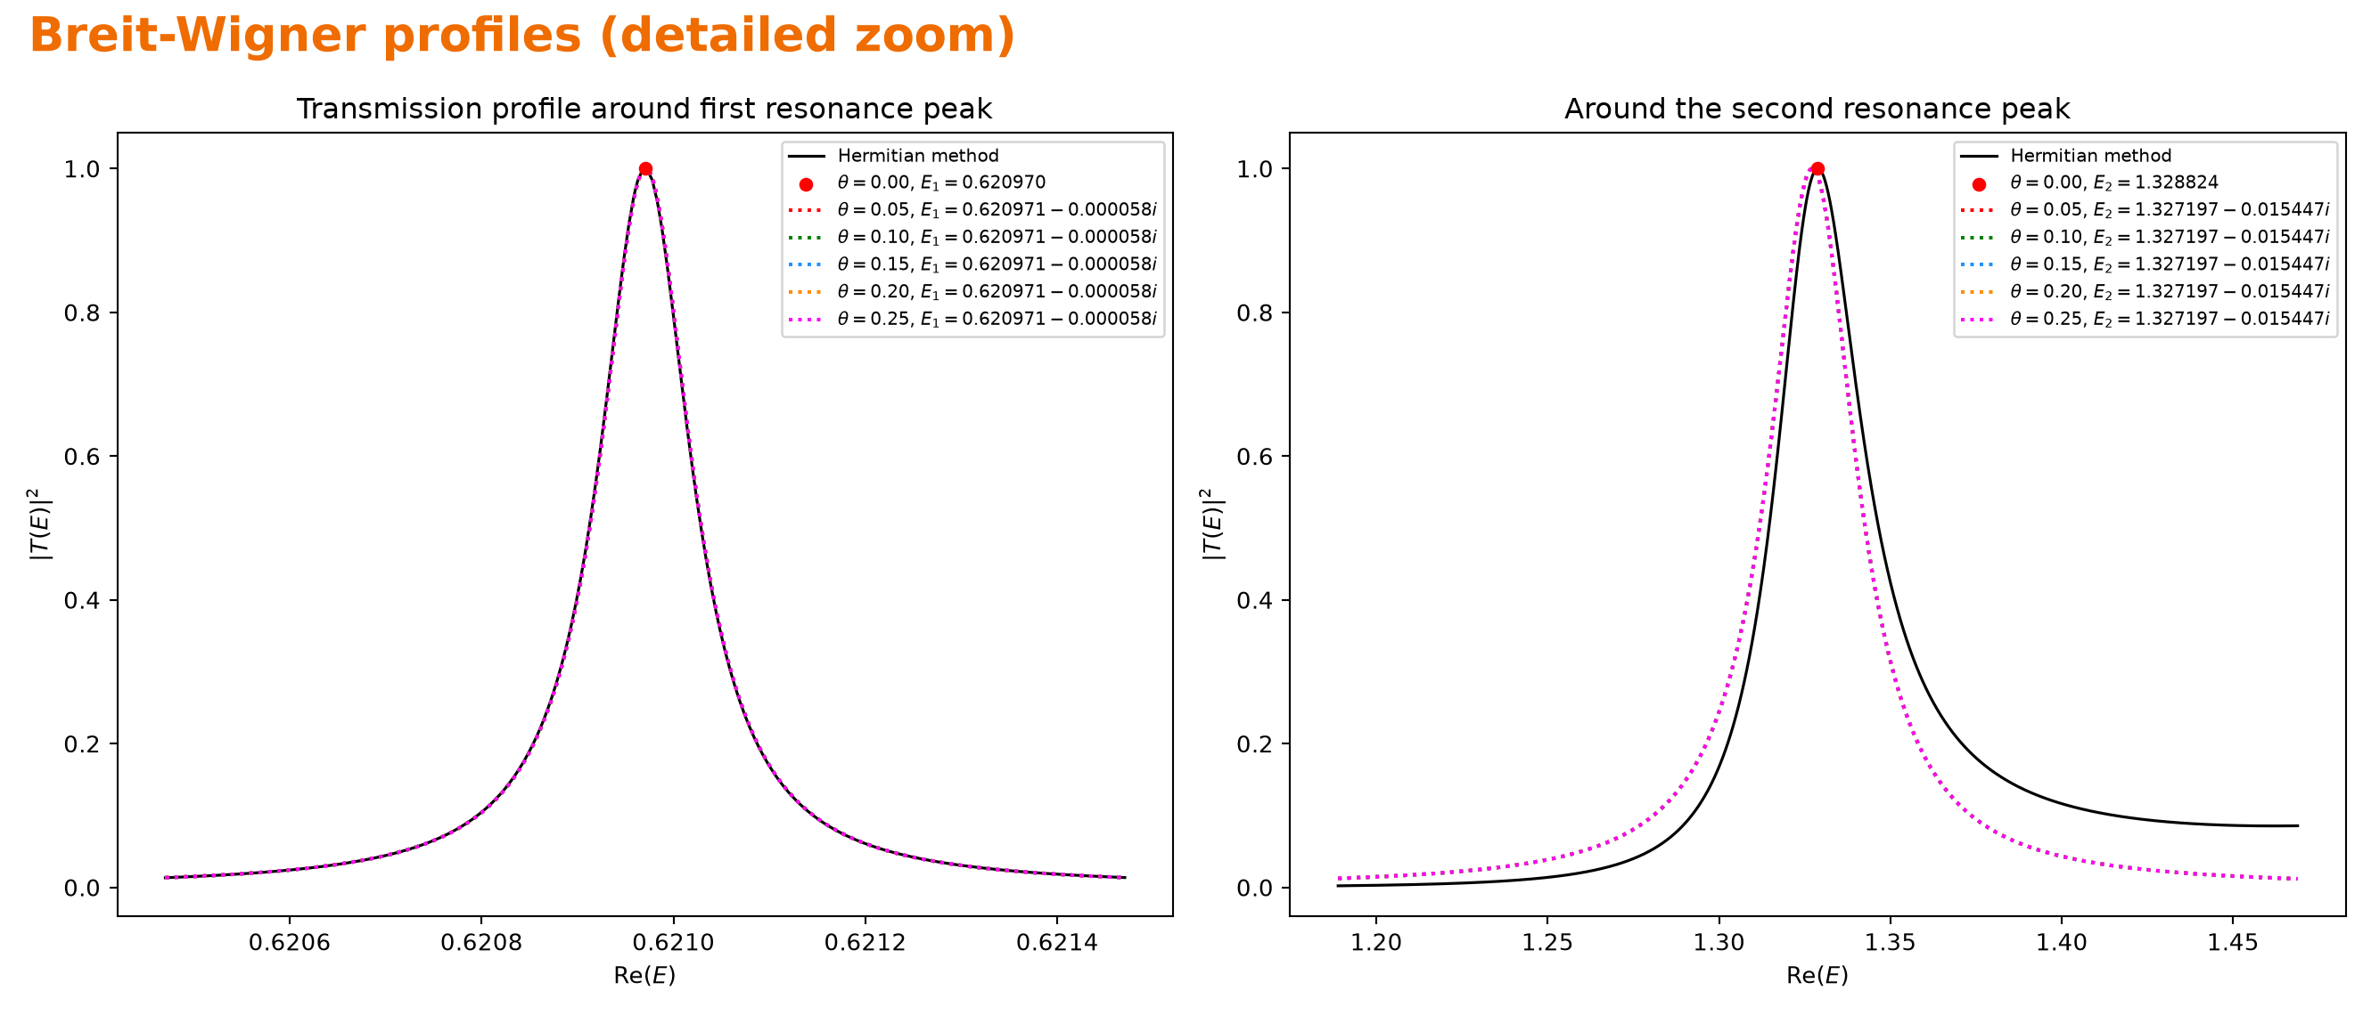
Figure 22. Detailed comparison around the first and second transmission peaks.
At the first resonance, the Breit-Wigner approximation nearly coincides with the Hermitian curve and reproduces its narrow line shape. For the second resonance, the center and overall width are still close, but the single-pole curve no longer follows the full profile away from the top. The remaining difference is attributed to the non-resonant background and the influence of broader resonances.

6.3 Resonance wavefunction
The last two figures show the second resonance state at Eres≈1.327197−0.015447i. The original Siegert state satisfies outgoing boundary conditions and grows at large |x|, so it is not square integrable. After the rotation ψθ(x)=ψ[x exp(iθ)] with θ=0.1, the same state decays away from the potential.
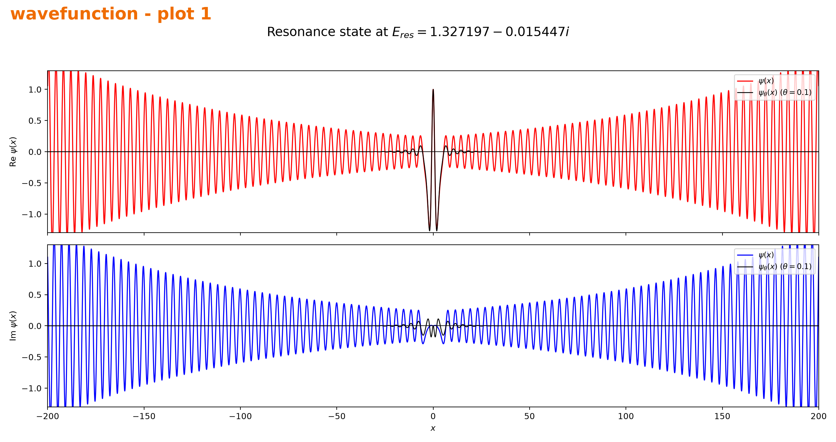
Figure 23. The second resonance wavefunction over −200≤x≤200 before and after complex scaling with θ=0.1.
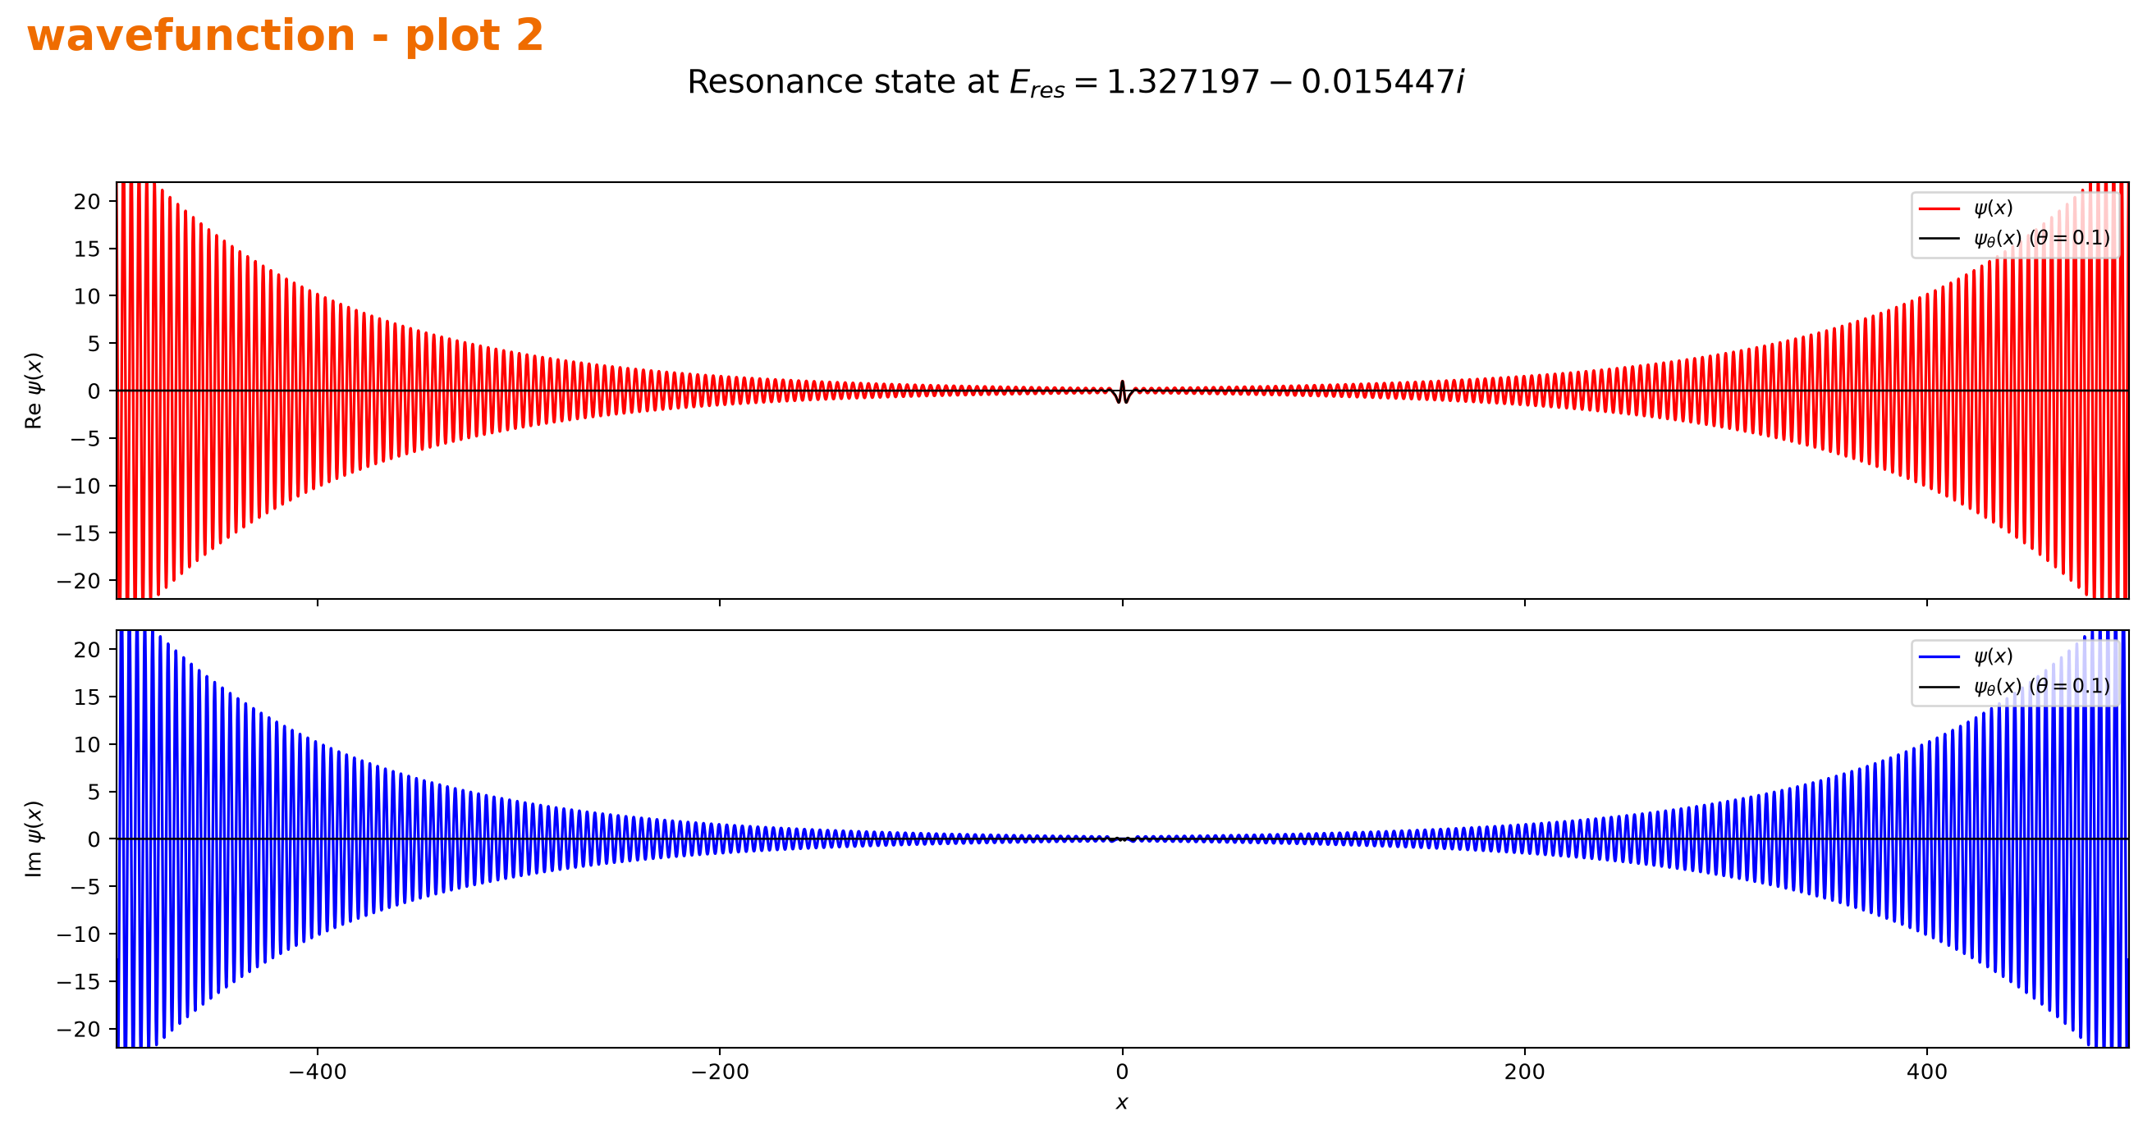
Figure 24. The same resonance state over −500≤x≤500, showing the outward growth of the unscaled state and the decay of the complex-scaled state.
The larger interval makes the different asymptotic behaviors clearer: the unscaled state continues to grow outward, whereas the complex-scaled state remains localized around the potential.

6.4 Comparison of resonance energies
The Hermitian scan in Part 3 gives peak energies E₁≈0.62097030 and E₂≈1.32882395, while complex scaling gives poles 0.620971−0.000058i and 1.327197−0.015447i. Comparing the Hermitian maxima with the real parts of these poles, the first values almost coincide and the second remain close, so both methods locate the same two resonance regions. Complex scaling also gives Γ₁≈0.000116 and Γ₂≈0.030894; the small shift of the second center is consistent with its broader, less isolated line shape.

